Week1 | Java Fundamentals-I -- features, tokens, control statements, class, object

Week2 | Java Fundamentals-II -- OOPS concepts ,non-access modifiers  inner classes, generics, wrapper classes

Week3 | Java Fundamentals-III – arrays, strings, access modifiers, packages,  regular expressions, Java new features

Week4 | Java lang & util packages

Week5 | Java File Handling

Week6 | Exception Handling , Java Concurency and Multithreadin

Week7&8 | Collections

Week1 | Java Fundamentals-I -- features, tokens, control statements, class, object

Week1 | Java Fundamentals-I -- features, tokens, control statements, class, object
INTERVIEW QUESTION:-
Give a few reasons for using Java?

- Object Oriented (OO).
- Better portability than other languages across operating systems.
- Built-in support for multi-threading, socket communication, and memory management (automatic garbage
collection).
- Supports Web based applications (Applet, Servlet, and JSP), distributed applications (sockets, RMI, EJB etc)
and network protocols (HTTP, JRMP etc) with the help of extensive standardized APIs (Application
Programming Interfaces).
- Robustness, through Exception Handling

INTERVIEW QUESTION:-
What is the main difference between the Java platform and the other software platforms?
Java platform is a software-only platform, which runs on top of other hardware-based platforms like UNIX, NT etc.

INTERVIEW QUESTION:-
What is the difference between C++ and Java?
- Java does not support pointers.
- Java does not support multiple inheritances instead Java supports multiple interface inheritance.
- Java does not support destructors but adds a finalize() method.
- Java does not include structures or unions because the traditional data structures are implemented as Java Collections Framework
- Java does not have global variables or functions.
- Java includes automatic garbage collection

INTERVIEW QUESTION:-
What are class loaders, types & differentiate static & dynamic class loading ?
The Java ClassLoader is a part of the Java Runtime Environment that dynamically loads Java classes into the Java Virtual Machine.
All classes are loaded based on their names and if any of these classes are not found then it returns a NoClassDefFoundError or ClassNotFoundException.

A Java Classloader is of three types
- Bootstrap or Primordial ClassLoader loads classes from the location of JDK
- Extension ClassLoader loads classes from the location jre/lib/ext
- System ClassLoader loads classes from the location of CLASSPATH

Static class loading | Dynamic class loading
Classes are statically loaded with Java’s “new” operator.  Car c = new Car(); | Dynamic loading is a technique for programmatically invoking the functions of a class loader at run time.  String myClassName = "au.com.Jeep" ;  Class vehicleClass = Class.forName(myClassName) ;  (Or)  myJeep = (Jeep) vehicleClass.newInstance();

INTERVIEW QUESTION:-

Difference between JDK, JRE, and JVM
Java Development Kit (JDK) is a software development environment that offers a collection of tools and libraries necessary for developing Java applications.
Java Runtime Environment(JRE) provides a platform to run and execute the source code. JRE contains JVM
Java Virtual Machine(JVM) provides the libraries to execute the program. The JVM, in turn, contains the JIT compiler.
Just-In-Time(JIT) compiler: It is used to improve the performance.JIT compiles parts of the bytecode that have similar functionality at the same time, and hence reduces the amount of time needed for compilation.

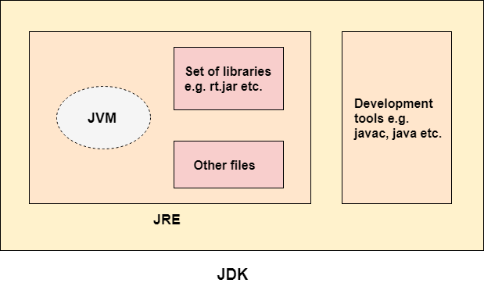

Java Tokens
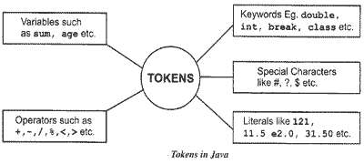
There are rules for naming identifiers.
- The characters allowed are [A-Z], [a-z], [0-9], _ and $.
- Identifiers are case-sensitive. That is, “var” is not the same as “VAR”.
- Identifier names should not start with a digit. For example, “1var” is an invalid identifier.
- Whitespace is not allowed inside an identifier.
- Keywords can’t be used as an identifier.

INTERVIEW QUESTION:-

Identify whether variable names are valid or not
- te-st
- 2var
- $2
- _var_

Welcome Program
Welcome.java
public class Welcome
{
public static void main(String args[])
{
System.out.println ("welcome to Java Coding");
}
}

public, class, static, void ---are keywords, all keywords strat with small letters
main()------ is a function, starting point of execution of a program
println()---is a predefined function used for printing on standard output device i.e, monitor

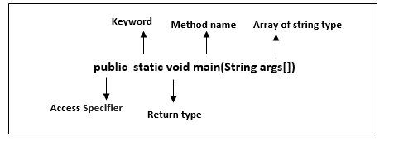

Note:-
Class name and java file name should be same.
Function names follow camelcap’s
Class names follow initial cap’s
main method----
main() method is the starting point of execution of a program.
main() method can take String array as argument
main() method can be overloaded but not overridden

INTERVIEW QUESTION:-
Why main() method is static & public ?
The main() method is static so that JVM can invoke it without instantiating the class
It is made public so that JVM can invoke it from outside the class as it is not present in the current class.

The java command-line argument is an argument i.e. passed at the time of running the java program. These command line arguments can be received in the java program by using the argument of main() method “String args[]”

Task:
Swapping 2 numbers without using a 3rd variable

Method1:Using Temporary Variable
To swap two numbers using third variable we have to declare a temp variable.
temp=x; //contains of x will be assigned to temp
Again y value we will assign to x .x value will be replaced with y value.
x=y;
Now temp value we will assign to y .
y=temp;

Method2:Without Using the Temporary Variable – Addition & Subtraction Operators

Way 1:
x=x+y;
y=x-y;
x=x-y;

Way 2:
a = (a + b) - (b = a);

Method3:Without Using the Temporary Variable – Bitwise XOR Operator (^)
x=x^y
y=x^y
x=x^y

Method4:Without Using the Temporary Variable – Multiplication & Division Operators

Way 1:
a = a * b;
b = a / b;
a = a / b;

Way 2:
a = (a * b) / (b = a);

Task:
Print all the arguments passed from the command-line
Input:-java CmdLineArgs This is command line argument program

class CmdLineArgs{
public static void main(String args[]){
for(int i=0;i<args.length;i++)
System.out.println(args[i]);
}
}
Output:-
This
is
command
line
argument
program

INTERVIEW QUESTION:-
Can a java program be executed without main() method?
Prior to JDK 7, the main method was not mandatory in a java program.
However, from JDK7 main method is mandatory.
JVM executes a static block on the highest priority basis. It means JVM first goes to static block even before it looks for the main() method in the program.

yes,one of the way is static block but in previous version of jdk1.7
public class WithoutMain
{
static {
System.out.println("hai");
System.exit(0); // prevents “main method not found” error
}
}

The order of code execution in a Java class is as follows.
- Static variables are initialized.
- Static blocks are executed.
- Instance variables are initialized.
- Instance blocks are executed.
- Constructor is executed.
- Static methods can be called without creating an instance.

System----
System is a part of java.lang package. System indicates the current computer system.
and one of its main features is to give us access to the standard I/O streams, one for each stream:
- out-- indicates standard output device, a static data member of type output stream class OutputStream.
- err-- represents standard error and we use that specifically to output error messages
- in--- indicates standard input device, a static data member of type input stream class InputStream.
Ways to read input from console in Java
- Using System.in.read()
- Using Buffered Reader Class
- Using Scanner Class
- Using Console Class

System.in.read() | BufferedReader | Scanner | console
For reading I/P in bytes form.  abstract method of abstract class InputStream  Using low level method may be prone to errors. | For reading all kinds of data  Synchronized  Efficient reading as I/P is buffered & faster as it just reads the stream doesn’t parse the tokens. | For reading primitive data types  Not Synchronized  Simple way of reading I/P & slower since it parse the tokens. | For reading password like I/P without echoing  Synchronized  But works with only non-interactive environment i.e, command line
int ch= System.in.read(); | BufferedReader reader = new BufferedReader(new InputStreamReader(System.in));  String name=reader.readLine(); | Scanner in = new Scanner(System.in);  String s;  s=in.nextLine();  int a=in.nextInt();  float b = in.nextFloat(); | String name = System.console().readLine();

Task:
Guess the Output:-
import java.io.IOException;
class System_In_Read {
public static void main(String[] args)throws IOException {
char ch, ch2;
System.out.print("Enter two characters: ");
ch = (char) System.in.read();
ch2 = (char) System.in.read();
int x1=ch;
int x2 = ch2;
System.out.println("x1="+x1+" | x2="+x2);
if (ch == ch2)
System.out.println("Same");
else
System.out.println("different");
}
}
Input:-
a
a
Output:-
x1=97 | x2=10
different
Explanation:-
read() method is a type of input stream that reads the next byte of data from input stream . However, pressing the enter key adds extra byte to the input stream, which is always stored in ch2.
Task:
Their exist two lines of input each consist of single integer, read these two integers using BufferedReader Class and then print both of them on a single line in a space-separated manner.
Input Format
Input consist of two lines.
Both of the lines contains a single integer.
Output Format
Print both of the integers on a single line in a space-separated manner.
Example Input
Input 1:
12
1
Output:
12 1

Solution:-
import java.lang.*;
import java.util.*;
import java.io.BufferedReader;
import java.io.IOException;
import java.io.InputStreamReader;
class Test {
public static void main(String[] args) throws IOException {
BufferedReader reader = new BufferedReader(new InputStreamReader(System.in));
String s1=reader.readLine();
String s2=reader.readLine();
System.out.println(s1+" "+s2);
}
}

INTERVIEW QUESTION:-
What value does read() return when it reaches the end of a file?
Ans: The read() method returns -1 when it reaches the end of a file.
What value does readLine() return when it has reached the end of a file?
Ans: The readLine() method returns null when it has reached the end of a file.
Control statements
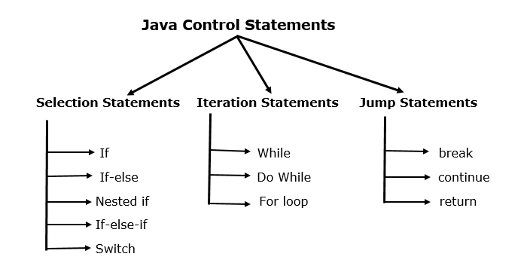
Switch:--
The Java switch statement executes one statement from multiple conditions  The case value must be literal or constant.  A switch works only with four primitives and their wrappers as well as with the enum type and the String class  - byte and Byte  - short and Short  - int and Integer  - char and Character  - enum  - String | switch(expression){  case value1:  //code to be executed;  break; //optional  case value2:  //code to be executed;  break; //optional  ......  default:  code to be executed if all cases are not matched;  }

INTERVIEW QUESTION:-
Guess the O/P:-
class Test {
public static void main(String[] args) {
String cat="CAT";
String animal="CAT";
switch (animal) {
case cat: //does not compile
System.out.println("cat");
}
}
}
Hint:- The case value must be literal or constant, so it should be made final
Task:
Write a Java program to print the Climatic Season of your place.
Months Season
12,1,2 Winter
3,4,5 Spring
6,7,8 Summer
9,10,11 Monsoon
Anything else entered - "Invalid Month"

LOOPS:-- for, while & do while
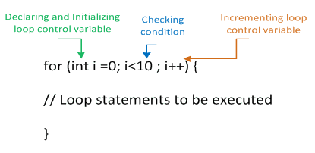
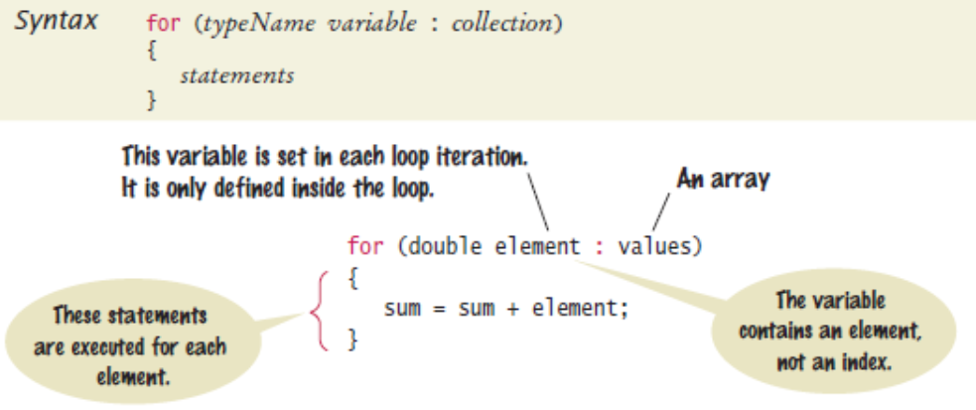

break statement, it jumps the control out of loop or switch block.
continue statement, will skip the execution of current loop iteration & continue with next iteration

INTERVIEW QUESTION:
Guess the O/P:-
class Test {
public static void main(String[] args) {
for (int i = 0; ; i++) {
System.out.println(i);
}
}
}

INTERVIEW QUESTION:
Guess the O/P:-
class Test
{
public static void main (String args[])
{
for(int i=0; 0; i++)
{
System.out.println("Hello Javatpoint");
}
}
}
Task

Pyramid Program
*
* *
* * *
* * * *
* * * * *
Solution:-
public class Pyramid
{
public static void pyramidPattern(int n)
{
for (int i=0; i<n; i++) //outer loop for number of rows(n) {
for (int j=n-i; j>1; j--) //inner loop for spaces
{
System.out.print(" "); //print space
}
for (int j=0; j<=i; j++ ) //inner loop for number of columns
{
System.out.print("* "); //print star
}
System.out.println(); //ending line after each row
}
}
public static void main(String args[]) //driver function
{
int n = 5;
pyramidPattern(n);
}
}

Task

Number Pattern Program in java
1
2 3
4 5 6
7 8 9 10
11 12 13 14 15

INTERVIEW QUESTION:-
Differentiate continue & break (or) Guess the O/P:-
class Test {  public static void main(String[] args) {  for (int i = 0; i<50 ; i++) {  if (i%2==0 && i >= 10) {  continue;  }  System.out.println(i);  }  }  } | class Test {  public static void main(String[] args) {  for (int i = 0; i<50 ; i++) {  if (i%2==0 && i >= 10) {  break;  }  System.out.println(i);  }  }  }

INTERVIEW QUESTION:-
Difference between while & do while loop
Differentiate between break & continue

Task:
Write a Java program to read the following inputs from the user - Name, Rollno, height and weight. And check whether the height is greater than 170 and weight is less than 60kgs. If these conditions are satisfied the candidate is eligible to become an NCC cadet, otherwise print not eligible.
Class, Object, Constructors
Real world Terms | Programming Terms
Entity | Class, is a single unit of combination of variables & methods(logical entity)  Object, is an instance of class (a physical entity)
Properties | Variables, stores data of an entity
charactertics | Methods, gives the functionality of an entity

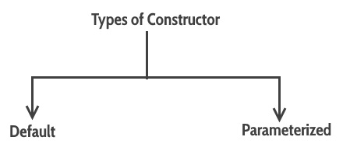

NOTE:- If you do not implement any constructor in your class, Java compiler inserts a default constructor into your code on your behalf. This constructor is known as default constructor.

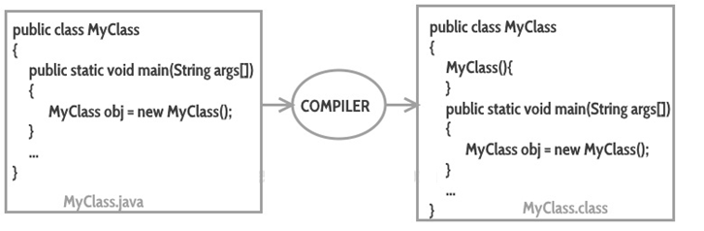
Task :
Create a student class with roll number, name & address as data members, initialize and display student details.
class Student{
int rollno; // Instatnce variables
String name;
String address;
Student(){ // Default Constructor
this.address="MRUH";
}
Student(int r,String n){ // Parameterized Constructor (2 argument)
this(); // refers the default constructor
this.rollno=r;
this.name=n;
}
Student(int r,String n, String a){ // Parameterized Constructor (3 argument)
this.rollno=r;
this.name=n;
this.address=a;
}
void addStudentRecord(int r, String n,String a){ // Instance method
rollno=r;
name=n;
address=a;
}
void displayDetails() // Instance method
{
System.out.println(rollno+" "+name+" "+address);
}
}
class Test{
public static void main(String args[]){
Student s1=new Student(101,"Akhil","HYD");
Student s2=new Student(102,"Bindhu");
Student s3=new Student();
s3.addStudentRecord(103,"Chanran","SEC");
s1.displayDetails();
s2.displayDetails();
s3.displayDetails();
}
}
Student Class  Rollno  name  address  addStudentRecord()  displayDetails() | Test Class  S1 S2 S3  101 Akhil HYD 102 Bindhu MRUH 103 Chanran SEC  main()

Explanation:-
Student s1=new Student(101,"Akhil","HYD"); invokes the 3 argument parameterized
Constructor to initialize all 3 variables
Student s2=new Student(102,"Bindhu"); invokes the 2 argument parameterized
Constructor initializing rollno & name. And
this() function call invokes the default
constructor to initialize address varaiable
Student s3=new Student();
s3.addStudentRecord(103,"Chanran","SEC"); invokes addStudentRecord() method
to initialize all variables
this keyword refers to the current object
Ex:- this.rollno=r;

this() , invokes another constructor of the same class & it should be the first statement in the constructor code
INTERVIEW QUESTION:-
this vs this()?
INTERVIEW QUESTION:-
When do we don’t use this?
If local variables(formal arguments) and instance variables are different,there is no need to use this keyword.
int i,j; int i,j;
Void add(int i,int j){ Void add(int a,int b){
this.i=i; i=a;
this.j=j; j=b;
} }
INTERVIEW QUESTION:-

Anonymous object
- Anonymous simply means nameless.
- An object which has no reference is known as an anonymous object.
- It can be used at the time of object creation only.
- If you have to use an object only once, an anonymous object is a good approach.
Example:-
new Student(101,"Akhil","HYD"). displayDetails();
INTERVIEW QUESTION:-
Constructor chaining, When A constructor calls another constructor of same class then this is called constructor chaining.
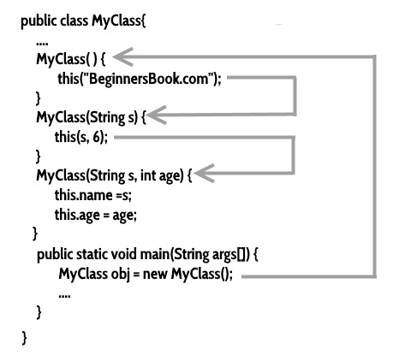

toString() method
------------------------
toString() method is the string representation of class
the toString() method’s default implementation gives a String that describes the
class name + ‘@’+ hashcode value of the object
toString() method can be overriden
public String toString() { } giving your own string representation of class.

INTERVIEW QUESTION:-
Shallow vs deep comparision
equals() method
---------------------
In java equals() method is used to compare equality of two Objects. The equality can be compared in two ways:

Shallow comparison: The default implementation of equals method is defined in Java.lang.Object class which simply checks if two Object references (say x and y) refer to the same Object. i.e.
It checks if x == y without comparing the data members that define its state, it is also known as shallow comparison.

Deep Comparison: Suppose a class provides its own implementation of equals() method in order to compare the Objects of that class w.r.t state of the Objects.
That means data members (i.e. fields) of Objects are to be compared with one another. Such Comparison based on data members is known as deep comparison.

equals() and hashCode() methods in Java
-----------------------------------------------------
hashCode() method returns the hashcode value as an Integer. Hashcode value is mostly used in hashing based collections like HashMap, HashSet, HashTable….etc.
This method must be overridden in every class which overrides equals() method.
Syntax :
public int hashCode(){}
INTERVIEW QUESTION
NOTE:-hashCode() method must be overridden in every class which overrides equals()
contract of hascode with equals()
- If two Objects are equal, according to the equals(Object) method, then hashCode() method must produce the same Integer on each of the two Objects.
- If two Objects are unequal, according to the equals(Object) method, It is not necessary the Integer value produced by hashCode() method on each of the two Objects will be distinct.

@Override
public boolean equals(Object obj)
{
// checking if both the object referring to the same object.
if(this == obj)
return true;
if(obj == null || obj.getClass()!= this.getClass())
return false;
// type casting of the argument.
Student stud = (Student) obj;
// comparing the state of argument with the state of 'this' Object.
return (stud.name == this.name && stud.rollNumber == this.rollNumber);
}

@Override
public int hashCode()
{
return this.rollNumber;
}
}
INTERVIEW QUESTION
equals() vs ==

INTERVIEW QUESTION:-
How to copy an object in Java?
1) Shallow copy: You can create a new object and copy the reference of the original object to the new object. This is known as a shallow copy.
Student student1 = new Student(101,"Naresh");
Student student2=student;
2) Deep copy:
- Copy constructor
- overriding the Cloneable interface's clone() function

Copy Constructor , creates an exact duplicate of an object it initializes new instances with the same values as existing ones, facilitating deep copies and value swapping without affecting the original object's state.
To create a copy constructor, we need to take the existing object as an argument and initialize the values of instance variables with the values obtained in the object.
public class Student
{
private int roll;
private String name;

// Copying each field of the existing object into the newly created object
public Student( Student student )
{
this.id = student.roll;
this.name = student.name;
}
}

overriding the Cloneable interface's clone() function
class Student implements clonable{
………
}
try {
Student S1= new Student(1,”Hari”);
Student S2= (Student)S1.clone();
}catch (CloneNotSupportedException e) {
e.printStackTrace();
}

Week2 | Java Fundamentals-II -- OOPS concepts ,non-access modifiers  inner classes, generics, wrapper classes

- Encapsulation
- Abstraction
- Polymorphism
- Inheritance

Encapsulation

To achieve encapsulation in Java −
- Declare the variables of a class as private.
- Provide public setter and getter methods to modify and view the variables values.

Encapsulation gives maintainability, flexibility and extensibility to our code.
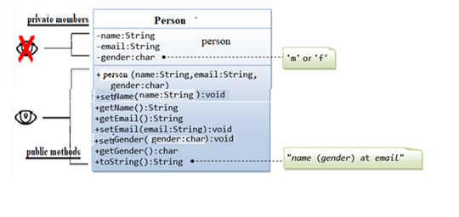
NOTE:- Private data members are acces through public member functions.
The Person class has three fields – name , email & gender. All are declared as private, meaning they can not be accessed directly outside the class.
The getter and setter methods : getName, setName,…ect. are declared public. Those methods are exposed to “outsiders” and can be used to change and retrieve data from the Person object.
toString() method makes it easier to output debugging traces, or makes better logging messages, since you can use the object's string representation provided by toString() directly; you don't have to manually build a string that gives the information needed on the object.

Abstraction
Abstraction is a process of hiding the complexity from end the user.

abstract method, method with no implementation

concrete method, method with implementation
concrete class is a class that has an implementation for all of its methods
abstarct class is a class that has one abstract method
There are two ways to achieve abstraction in java
1.Abstract class (0 to 100%) | 2.Interface (100%)

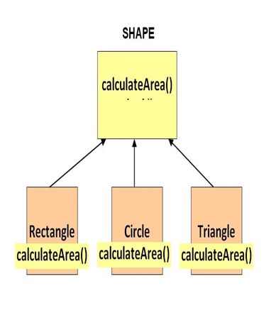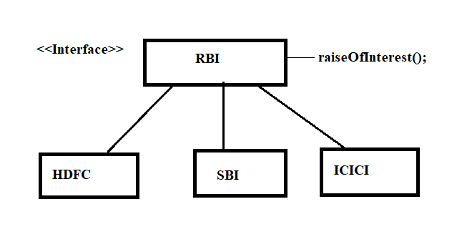
It can have constructor and static methods also.  It can have final methods | The interface keyword is used to declare an interface.  Example  interface Person  {  //Data members will be made public static final  //Member functions will be made public abstract.  }

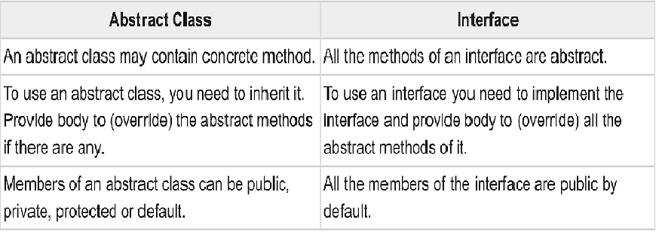

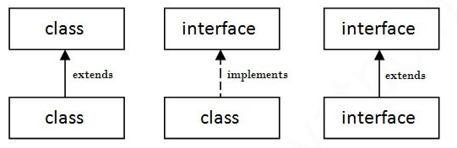

PROBLEM STATEMENT:-
Build java program for the following class structure.
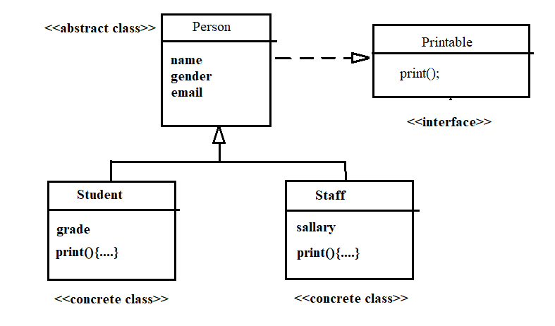
When to use abstract:--
If you want to provide some common or default functionality then the abstract class would be a better choice.
When to use interface:--
If you want to enforce some rule or want to make a contract of implementation the interface would be a better choice. To support multiple inheritance
NOTE:- We can use the abstract class and interface together. An interface can provide only a contract but by use of an abstract class, we can provide skeletal of that contract.
INTERVIEW QUESTION
What is marker interface?
A marker interface is an interface that doesn't have any methods or constants inside it. It provides run-time type information about objects, so the compiler and JVM have additional information about the object. A marker interface is also called a tagging interface.
INTERVIEW QUESTION

INTERVIEW QUESTION
Super keyword vs super()?
The super keyword in Java is a reference variable that is used to refer parent class objects. The super() in Java is a reference variable that is used to refer parent class constructors. super can be used to call parent class' variables and methods. super() can be used to call parent class' constructors only.
Association, is the relationship between two classes
one-to-one  A person can have only one passport. | one-to-many  A person can have many mobile phones. | many-to-one  Many Books in one Library | many-to-many  A student can have multiple teachers and a teacher can have multiple students.
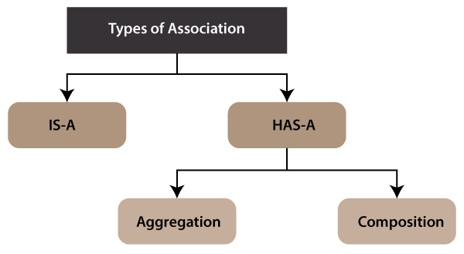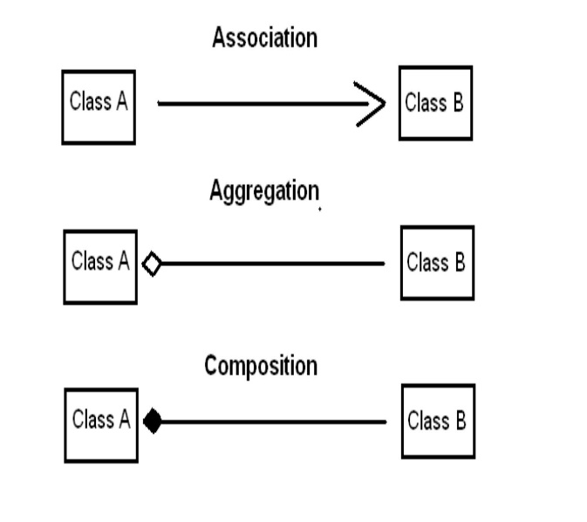

NOTE:-When there is an aggregation between two entities, the aggregate object can exist without the other entity, but in the case of Composition, the composed object can't exist.

INTERVIEW QUESTION
Association(is-a) vs Aggregation(has-a) vs Composition(has-a)

PROBLEM STATEMENT:-
Build java program for the following class structure.
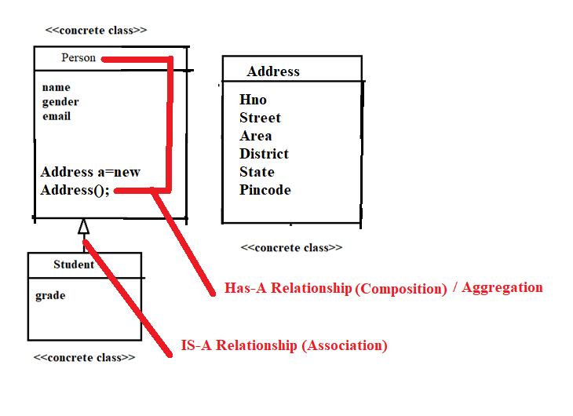

Why use Aggregation?
- For Code Reusability.

Why use Association?
- runtime polymorphism can be achieved).
- For Code Reusability.
NOTE:-we cannot use this() and super() keywords in the same block.
INTERVIEW QUESTION
super vs super()
The super keyword in Java is a reference variable that is used to refer parent class objects. The super() in Java is a reference variable that is used to refer parent class constructors. super can be used to call parent class' variables and methods. super() can be used to call parent class' constructors only.

Polymorphism

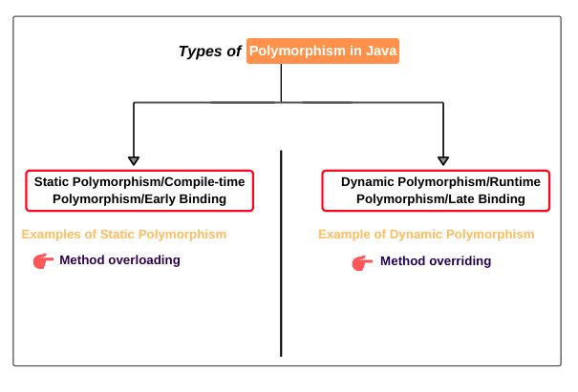

Inheritance

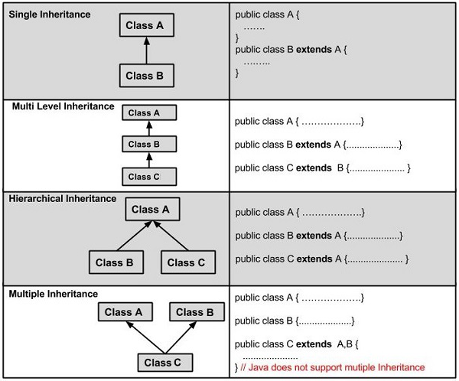
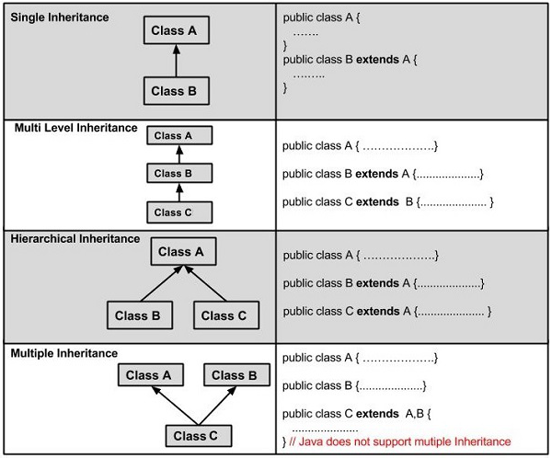

Aggregation vs composition

The super keyword in Java refer parent class data member or constructor or method

Super()
Whenever a child class constructor gets invoked it implicitly invokes the constructor of parent class.

Non-access Specifiers
Static
Final

The static keyword in Java is used for memory management
The static can be:
- Variable (also known as a class variable)
- Method (also known as a class method)
- Block
- Nested class
There are two main restrictions for the static method. They are:
- The static method can not use non static data member or call non-static method directly.
- this and super cannot be used in static context.

Static variable  Class variable, shared among all objects  Static member can be accessed without reference to any object.  Static variables cannot access non-static members of a class, | Staic block  - Is used to initialize the static data member.
Static method  Any static member can be accessed before any objects of its class are created, and without reference to any object  Static methods cannot access non-static members of a class.  Static methods can be overloaded, but not overridden  - They cannot refer to this or super in any way. | Static class  A class can be made static only if it is a nested class.  Nested static class doesn’t need a reference of Outer class. In this case, a static class cannot access non-static members of the Outer class.

- static block and static variables are executed in the order they are present in a program.

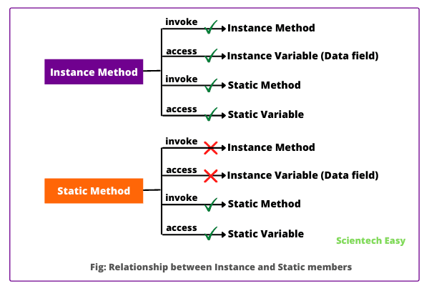

Guess the O/P
class Test
{
// static variable
static int a = 10;
public static void main(String[] args)
{
int a = 20;
// Cannot use super in a static context
System.out.println(super.a); // compiler error
}
}
WAP to create student records getting unique rollNo through the use of static variable

Can a non-satic method acces static data member?
NO

Final

The final keyword in java is used to restrict the user. The java final keyword can be used in many context. Final can be:
- variable
- method
- class 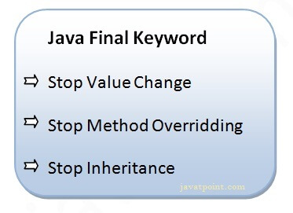
A final variable that have no value it is called blank final variable or uninitialized final variable.
It can be initialized in the constructor only.
The blank final variable can be static also which will be initialized in the static block only.

Java final variable
If you make any variable as final, you cannot change the value of final variable(It will be constant).

INTERVIEW QUESTION

Is final method inherited?
Ans) Yes, final method is inherited but you cannot override it.

What is blank or uninitialized final variable?

Can we declare a constructor final?
No, because constructor is never inherited.
Inner Classes
Java inner class or nested class is a class that is declared inside the class or interface.
use inner classes to logically group classes and interfaces in one place to be more readable and maintainable.
NOTE:-An instance of an inner class cannot be created without an instance of the outer class
Note that inner classes can access outer class private members and at the same time we can hide inner class from outer world.
Java inner class is defined inside the body of another class. Java inner class can be declared private, public, protected, or with default access whereas an outer class can have only public or default access.
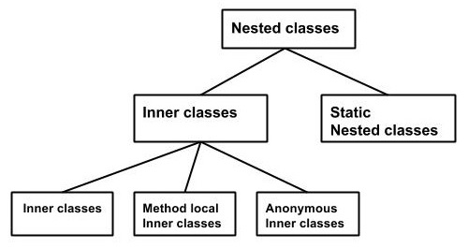
Types of inner classes
- Non-static nested class (inner class)
  - Member inner class
  - Anonymous inner class
  - Local inner class
- Static nested class

Inner class example | Static nested class example

Realtime Example of Inner class

1. Suppose there is a university. University contains several departments such as electronics, computer science, electrical, mechanical, etc.
Assume that tomorrow, the government decided to close this university due to its illegal activity happening in the university. If the university is closed, all departments of this university will be closed automatically.
That’s why we can say that departments are tied to its university. i.e. their functionalities are tied with its university. So, without an existing university object, there is no chance of existing department objects.
Since the department is always a part of the university class. Hence, we must declare the department class inside the university class.
class University { // University is outer class.
. . . . . . .
class Department { // Department is inner class.
. . . . . . . .
}
}

Scenario2:--
Let’s understand it with the help of realtime example program.
Assume that we create a class BankAcct. To get some bank account details, we define instance variables ‘balance’ and ‘rate’ of interest in the class.
calInterest() method calculates the interest amount and will display balance amount. Look at the following source code.
class BankAcct {
// Balance and Rate of interest.
private double bal;
private double rate;

// Calculating interest and updated balance.
void calInterest() {
double interest = bal * rate/100;
bal += interest;
System.out.println("Balance amount = " +bal);
}
}
As you observe that there is no security for this code because of not using any access modifiers before BankAcct class.
Since it is under default access modifiers, any programmer can easily create an object of this class and access the members of the class from outside other classes. Hence, there is no security for BankAcct class.
For example, any programmer can create another class. He will create an instance of BankAcct class and can change rate of interest like this:
class Myclass {
public static void main(String[ ] args ){
BankAcct ba = new BankAcct();
ba.calInterest(11.5);
}
}
Thus, calInterest() method is very sensitive. It must be protected from outsiders because the balance accounts can be updated from outside by any other person. Only authorized person should be able to update the balance accounts.

To provide security to calInterest() method and rate of interest, if we put code of calInterest() method inside an inner class and make it private, nobody can access them from outside class. Look at the code.
class BankAcct {
. . . . . . . .
private class Interest {
private double rate;
void calInterest() {
double interest = bal * rate/100;
bal += interest;
System.out.println("Balance = " +bal);
}
}}
Now the question is how to access the inner class?
To access the inner class, we will create a contact() method inside the outer class. Inside contact() method, we will create an object of inner class and can access members of it.
An authentication bank person can interact with inner class by calling contact() method. When contact() method will be called, it will verify with password and then he will be able to use the inner class and access it.
Thus, an inner class can provide a safety mechanism for important code in Java.

Types of Inner class in Java
- Normal or Regular Inner Class, A class created inside another class and outside the method without static modifier
- Method Local Inner Class, class declared within a method of the outer class
- Anonymous Inner Class, class declared without any name
- Static Nested Inner Class, A class declared with static modifier within a class

Note: The regular, method-local, and anonymous inner classes are non-static nested classes.

Generics
The Java Generics programming is introduced in J2SE 5 to deal with type-safe objects.
Type safety
Compile time checking
Type casting not required

Before generics, we can store any type of objects in the collection, i.e., non-generic. Now generics force the java programmer to store a specific type of objects.
With Generics, it is required to specify the type of object we need to store.

Before Generics
List list = new ArrayList();
list.add(10);
list.add("10");
String s = (String) list.get(1);//typecasting

With Generics, it is required to specify the type of object we need to store.
List<Integer> list = new ArrayList<Integer>();
list.add(10);
list.add("10");// compile-time error

List<String> list = new ArrayList<String>();
list.add("hello");
String s = list.get(0); //typecasting notrequired

Type Parameters
The type parameters naming conventions are important to learn generics thoroughly. The common type parameters are as follows:
- T - Type
- E - Element
- K - Key
- N - Number
- V - Value

Generic class  A class that can refer to any type is known as a generic class. Here, we are using the T type parameter to create the generic class of specific type.  List<String> list = new ArrayList<String>();  list.add("hello");  String s = list.get(0); //typecasting notrequired | Generic Method  A method that can accept any type of arguments is known as generic method. Here, we are using the E type parameter to denote the element of specific type as argument in generic method.  public class Test{  public static < E > void printArray(E[] elements) {  for ( E element : elements){  System.out.println(element );  }  System.out.println();  }  public static void main( String args[] ) {  Integer[] intArray = { 10, 20, 30, 40, 50 };  Character[] charArray = { 'J', 'A', 'V', 'A', 'T','P','O','I','N','T' };  System.out.println( "Printing Integer Array" );  printArray( intArray );  System.out.println( "Printing Character Array" );  printArray( charArray );  }  }

Wildcard in Java Generics
The ? (question mark) symbol represents the wildcard element. It means any type.
UpperBoundWildcard <? extends Number>  - import java.util.ArrayList;  - public class UpperBoundWildcard {  - private static Double add(ArrayList<? extends Number> num) {  - double sum=0.0;  - for(Number n:num)  - {  - sum = sum+n.doubleValue();  - }  - return sum;  - }  - public static void main(String[] args) {  - ArrayList<Integer> l1=new ArrayList<Integer>();  - l1.add(10);  - l1.add(20);  - System.out.println("displaying the sum= "+add(l1));  - ArrayList<Double> l2=new ArrayList<Double>();  - l2.add(30.0);  - l2.add(40.0);  - System.out.println("displaying the sum= "+add(l2));  - }  - } | UnboundedWildcard <?>  - import java.util.Arrays;  - import java.util.List;  - public class UnboundedWildcard {  - public static void display(List<?> list)  - {  - for(Object o:list)  - {  - System.out.println(o);  - }  - }  - public static void main(String[] args) {  - List<Integer> l1=Arrays.asList(1,2,3);  - System.out.println("displaying the Integer values");  - display(l1);  - List<String> l2=Arrays.asList("One","Two","Three");  - System.out.println("displaying the String values");  - display(l2);  - }  - }

Wrapper Classes:-

The wrapper class in Java provides the mechanism to convert primitive into object and object into primitive.
Since J2SE 5.0, autoboxing and unboxing feature convert primitives into objects and objects into primitives automatically. The automatic conversion of primitive into an object is known as autoboxing and vice-versa unboxing.

Interview Question
Autoboxing

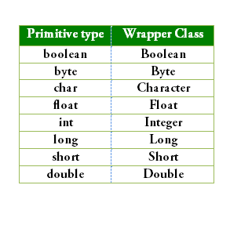
since Java 5, we do not need to use the valueOf() method of wrapper classes to convert the primitive into objects.
Since Java 5, we do not need to use the intValue() method of wrapper classes to convert the wrapper type into primitives.

//Converting int into Integer
int a=20;
Integer i=Integer.valueOf(a);//converting int into Integer explicitly
Integer j=a;//autoboxing, now compiler will write Integer.valueOf(a) internally

//Converting Integer to int
Integer a=new Integer(3);
int i=a.intValue();//converting Integer to int explicitly
int j=a;//unboxing, now compiler will write a.intValue() internally

Week3 | Java Fundamentals-III – arrays, strings, access modifiers, packages,  regular expressions, Java new features

An array is a collection of Homogenious data types (similar data type) which has contiguous memory location.
Arrays are declared with [] after the data type
index beginning with 0
Size of array is found by length property.
Java arrays can store only a fixed set of elements
Array Declarartion | Array Initialization
dataType[] arr; (or)  dataType []arr; (or)  dataType arr[]; | - arrayRefVar=new dataType[size];

Styles of array declarations in java
- int a[]=new int[5];
- int []b=new int[6];
- int c[];
c=new int[10];
- int d[]=new int[]{10,20,30};
NOTE:- java.lang.ArrayIndexOutOfBoundsException will be raised when tried to access ayyar elements out of index.
Array elements can be printed by using
A normal for loop | for each loop
- int a[]={33,3,4,5};  - for(int i=0;i<a.length;i++)  - System.out.println(a[i]);  - } | - int arr[]={33,3,4,5};  - for(int i:arr)  - System.out.println(i);  - }
NOTE:- Name of the array is equivalent to the address of zeroth elementof the array.
So to pass an array to a method , we can pass the name of the array.
INTERVIEW QUESTIONS
Can you pass the negative number in Array size?
No, you can not pass the negative number as Array size. If you pass a negative number in Array size then you will not get the compiler error. Instead, you will get the NegativeArraySizeException at run time.
Can you declare an Array without Array size?
No, you can not declare Array without Array size. You will get compile time error.
Where does Array stored in JVM memory ?
Array is an object in java. So, Array is stored in heap memory in JVM.

Which is legal int[] arr or int arr[] ?
Both are legal statements. It is preferred to write int[] arr instead of int arr[].

WAP to find largest value in the array.
Suppose given array is 173,29,391,41 then the largest value is 391
WAP to find intersection of two arrays in java?
Suppose given two arrays array1= {1,4,7, 9, 2} arrray2 = {1,7,3,4,5}
the answer should be {1,4,7}

WAP to merge two arrays in java?
If array1 is {1,2,3} and array2 is {4,5,6} then merged array will be {1,2,3,4,5,6}

Strings, a sequence or series of characters, enclosed in a pair of double quotes (“”).
In java, String is an immutable, once created, a String cannot be changed or modified and all such operations on a String lead to creation of a new String object.
The java.lang.String class implements Serializable, Comparable and CharSequence interfaces

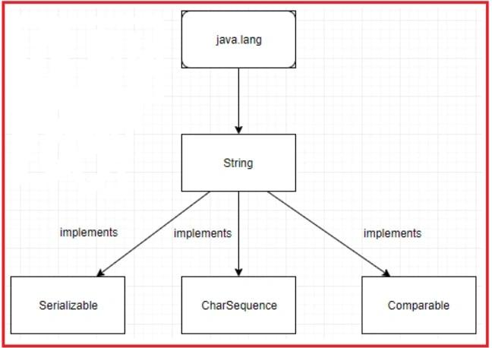

Difference Between String , StringBuilder And StringBuffer Classes
 | String | StringBuffer | StringBuilder
Storage | Constant String Pool | Heap | Heap
Modifiable | No (immutable) | Yes( mutable ) | Yes( mutable )
Thread Safe | Yes | Yes | No
Performance | Slow | Slow but faster than String | Fast
Example | String demo = "hello" ;  demo="Bye" ;  // "hello" string still exists in string constant pool and its value is not overrided but we lost reference to the "hello"string | StringBuffer demo1 = new StringBuffer("Hello");  demo1 = new StringBuffer("Bye");  // Above statement is right as it modifies the value which is allowed in the StringBuffer | StringBuilder demo2= new StringBuilder("Hello");  demo2=new StringBuilder("Bye");  / / Above statement is right as it modifies the value which is allowed in the StringBuilder

string created without using new keyword will be stored in Java String Pool

string created using new keyword will be stored in Java Heap
Every immutable object in Java is thread-safe
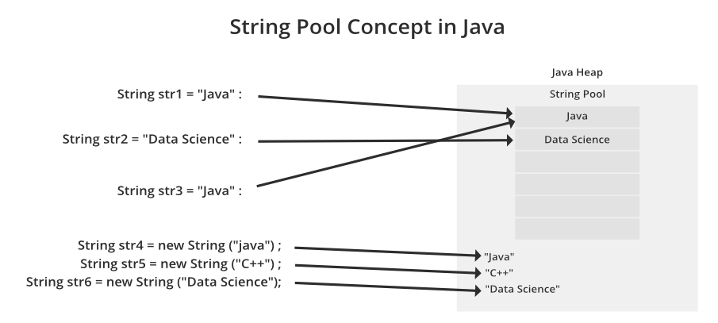
GUESS THE O/P
Sample Code Snippet #1:
String str1 = new String("java");
String str2 = new String("java");
System.out.println(str1 == str2);//false
String str1 = "java";
String str2 = "java";
System.out.println(str1 == str2);//true

Java String class provides a lot of methods to perform operations on strings such as compare(), concat(), equals(), split(), length(), replace(), compareTo(), substring() etc.

public int compareTo(String str)---for comparing two strings
returns 0 if equal
<0 if str1 is less than str2
>0 if str2 is less than str1

Most commonly used methods in String class
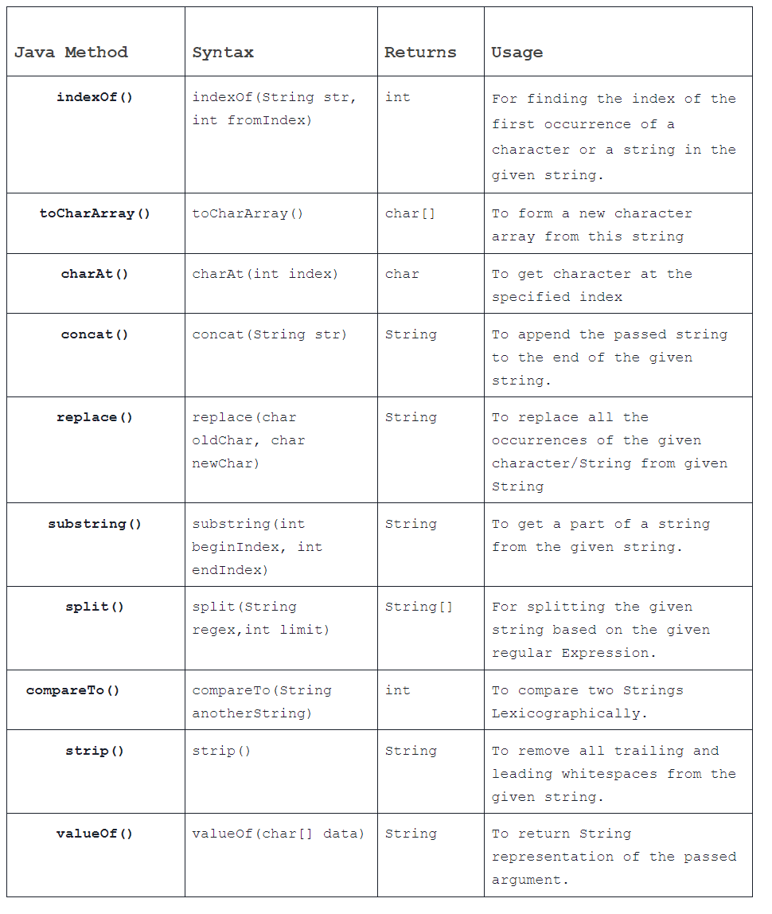

WAP to remove duplicate chars from the given string
- Using jav 8 + lamda expressions
- indexOf()
- character array
- set interface method
WAP to remove special char from the given string
replaceAll() & regular expression, replaceAll([^\\s ] ,””)

WAP to sort the string without using sort() method

WAP to reverse a string without using reverse() method.

WAP to find the first non repeated character in the String?
Input: programming
Output:First non-repeating character is: p

Java Regular expressions
The Java Regex or Regular Expression is an API to define a pattern for searching or manipulating strings.
Java Regex API provides 1 interface and 3 classes in java.util.regex package
- MatchResult interface
- Matcher class
- Pattern class
- PatternSyntaxException class
import java.util.regex.*;
public class RegexExample1{
public static void main(String args[]){
//1st way
Pattern p = Pattern.compile(".s");//. represents single character
Matcher m = p.matcher("as");
boolean b = m.matches();
//2nd way
boolean b2=Pattern.compile(".s").matcher("as").matches();
//3rd way
boolean b3 = Pattern.matches(".s", "as");
System.out.println(b+" "+b2+" "+b3);
}
}

Regex Character classes
Character class | Description
[xyz] | x,y or z
[^xyz] | Any characters other than x,y or z
[a-zA-Z] | characters from range a to z or A to Z.
[a-f[m-t]] | Union of a to f and m to t.
[a-z && p-y] | All the range of elements intersection between two ranges
[a-z && [^bc]] | a to z union with except b and c
[a-z && [^m-p]] | a to z union with except range m to p

Regex Metacharacters
Regex | Description
X? | X appears once or not
X+ | X appears once or more than once
X* | X appears zero or not once
X{n} | X appears n times
X{n,} | X appears n times or more than n
X{n,m} | X appears greater than equal to n times and less than m times.

Java Regex Finder Example
Regex | Description
. | Any character
\d | Any digits, [0-9]
\D | Any non-digit, [^0-9]
\s | Whitespace character, [\t\n\x0B\f\r]
\S | Non-whitespace character, [^\s]
\w | Word character, [a-zA-Z_0-9]
\W | Non-word character, [^\w]
\b | Word boundary
\B | Non -Word boundary

What is difference between matches() and find() in Java Regex?
matches() returns true only if the whole string matches the specified pattern while find() returns trues even if a substring matches the pattern.
WAP to validate email id using regular expressions
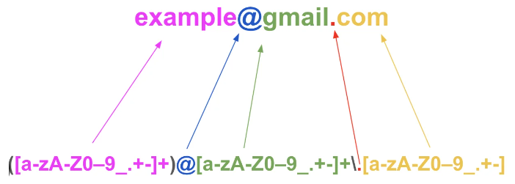
Java Lamda Expressions
An interface which has only one abstract method is called functional interface.
Lambda expression provides implementation of functional interface.

Java Lambda Expression Syntax:-- (argument-list) -> {body}
Java lambda expression is consisted of three components.
1) Argument-list: It can be empty or non-empty as well.
2) Arrow-token: It is used to link arguments-list and body of expression.
3) Body: It contains expressions and statements for lambda expression.

Java Packages
A java package is a group of similar types of classes, interfaces and sub-packages.
1) Java package is used to categorize the classes and interfaces so that they can be easily maintained.
2) Java package provides access protection.
3) Java package removes naming collision.
The package keyword is used to create a package in java.
To compile javapackages following command to be used
javac -d directory javafilename

Note: If you import a package, subpackages will not be imported.

Java Access Modifiers
The access modifiers in Java specifies the accessibility or scope of a field, method, constructor, or class.

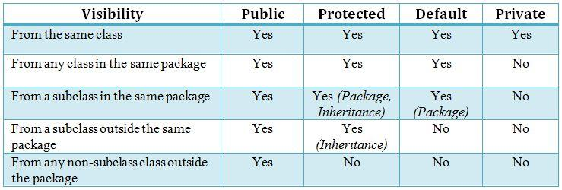
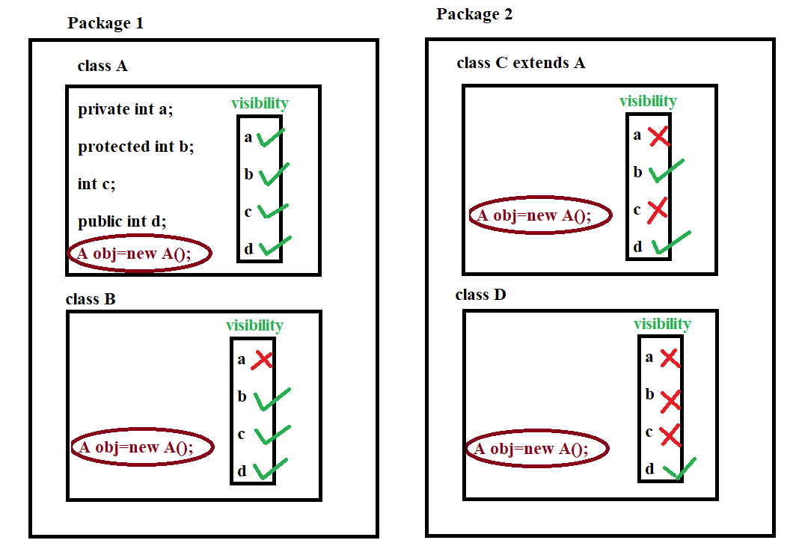

Week4 | Java lang & util packages

Guess The O/p
String str=”java”;
Str.concat(“programming”);
System.out.println(str);

NOTE:- For substring() operation String is preffered to StringBuilder since String will create new string for substring which refers to the old string where as StringBuilder creates a new string for substring & store the values. This is upto java 7 but after in both case substring maintains a copy.

Java.lang.Math Class
Java.lang.Math Class methods help to perform numeric operations like square, square root, cube, cube root, exponential and trigonometric operations.
Math is abstract class
all methods are static :-
int abs(int) int/float/long/double
int min(int,int) int/float/long/double
int max(int,int) int/float/long/double
ceil() 2.x - - 3
floor() 2.x -- 2
round() 2.5 -- 3 2.4 -- 2
pow(),log(),exp(),sqrt()
sin(),cos(),tan(),asin(),acos(),atan()
toDegrees() toRadians()
random() 0.0 to 1.0
static final datamembers:-
PI , E
constant Math.E is Eulers’s Number, the base of natural logarithms, e, which is approximately 2.718.
The Math.exp() static method returns e raised to the power of a number. That is
𝙼𝚊𝚝𝚑.𝚎𝚡𝚙(𝚡)=e^{x}

INTERVIEW QUESTION
Random Number generation in java
1) Math.random()
2) Random class and
3) ThreadLocalRandom class.
The Math.random() method in the java.math is static , thus it always return double value.The main advantage is its simplicity.
double random = Math.random();
System.out.println(random);
# Output: A random number between 0.0 (inclusive) and 1.0 (exclusive)

However, Math.random() only generates double values between 0.0 and 1.0. If you need to generate random integers or random numbers within a certain range, you’ll need to use a different approarch.
//To generate a random number between 10 and 50:
double random = 10 + (Math.random() * 40);
System.out.println(random);
# Output: A random number between 10.0 (inclusive) and 50.0 (exclusive)

While Math.random() is a simple and effective way to generate random numbers in Java, there are other methods that offer more flexibility and control. Let’s explore two of them:
Random class in Java is used to generate pseudo-random numbers. Unlike Math.random(), the Random class can generate both integer and floating-point numbers, and it allows you to specify a range.

//To generate a random number between 10 and 50
import java.util.Random;
Random rand = new Random();
int random = 10+rand.nextInt(40);
System.out.println(random);
# Output: A random number between 10(inclusive) and 50 (exclusive)

The ThreadLocalRandom class in Java is another option for generating random numbers. It’s especially useful in multi-threaded environments, as it reduces contention and overhead associated with Random.
first import the ThreadLocalRandom class. We then use the current method to get the current thread’s ThreadLocalRandom, and call its nextInt method to generate a random integer.
//To generate a random number between 10 and 50
import java.util.concurrent.ThreadLocalRandom;
int random = 10+ThreadLocalRandom.current().nextInt(40);
System.out.println(random);
# Output: A random number between 10 (inclusive) and 50(exclusive)

INTERVIEW QUESTION:-

What does the string intern() method do in Java?
If you apply the intern() method to a few strings, you will ensure that all strings having the same content share the same memory. As soon as a String object is invoked with intern(), it first checks if the string value of the String object is already present in the string pool and if it is available, then the reference to that string from the string constant pool is returned. If not, a new string object is added to the string pool, and a reference to it is returned.
Guess the O/P
System.out.println(Math.min(Double.MIN_VALUE, 0.0d));
Ans:-0.0
Guess the O/P
System.out.println(20+ +9- -12+ +4- -13+ +19);
The statement can be written and solved as follows:(20+ (+9)- (-12)+ (+4)- (-13)+ (+19));
=20+9+12+4+13+19=77

Guess the O/P
(int)(3*Math.random()) 0,1,2

Which of the following statement runs infinitely?
i. for( ; ; )
ii. for( ; true; )
iii. for( ; false; )
iv. for( ; 2==2; )
v. for(int i=1; i>=1; i++)
Ans:- i, ii, iv, v
Java.lang.Enum Class
Enum, introduced in Java 5, is a special data type that consists of a set of pre-defined int constants named values separated by commas. These named values are also known as elements or enumerators or enum instances. Since the values in the enum type are constant, you should always represent them in UPPERCASE letters.

The following characteristics make enum a ‘special’ class:
- enum constants cannot be overridden
- enum doesn’t support the creation of objects
- enum can’t extend other classes
- enum can implement interfaces like classes
to define an Enum type, the ‘enum’ keyword is used
enum Variable_Name { VALUE_1, VALUE_2, VALUE_3, … }

Internal implementation of enum:
Internally enum's are implemented by using class concept.
Every enum constant is a reference variable to that enum type object.
Every enum constant is implicitly public static final always.
Example 3:
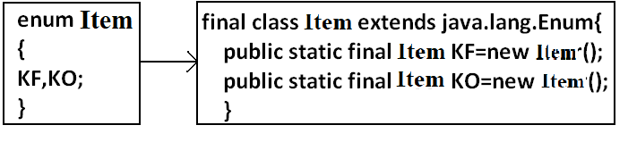
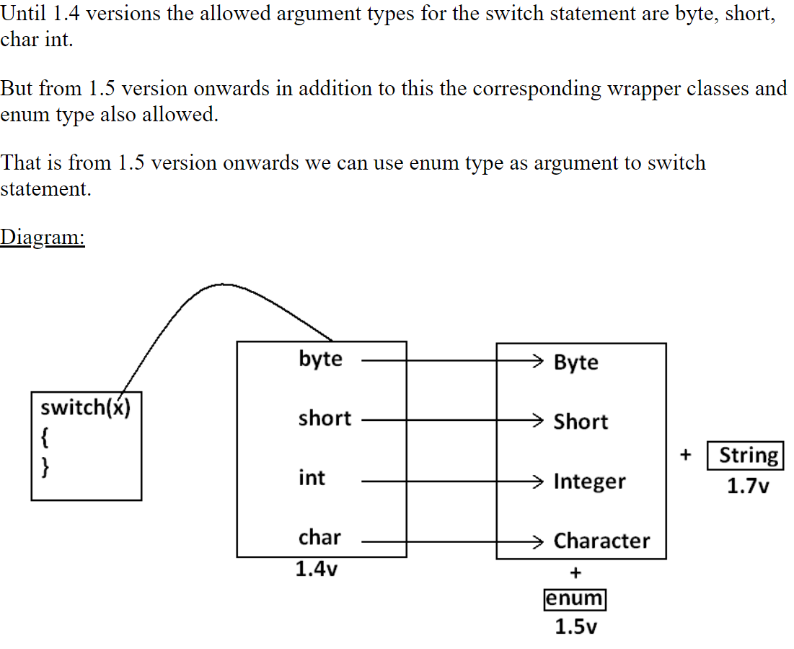

Java Date and Time
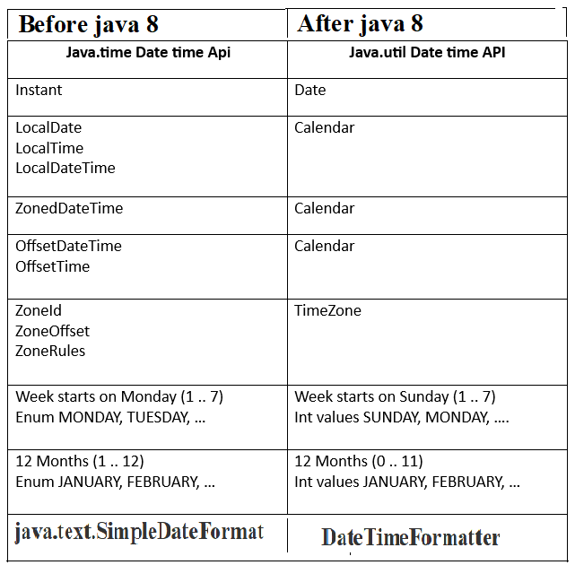
java.util.Date Class
Date Class represents a specific point in time, in milliseconds.. It provides methods to manipulate and format dates, as well as perform arithmetic and comparison operations. Internally the class uses a base or reference date of January 1, 1970, 00:00:00 GMT (also known as the Unix epoch).

Date(): Creates an object representing the current date and time.
Date(long millis): Creates a Date object with the specified number of milliseconds since
January 1, 1970, 00:00:00 GMT (the Unix epoch).
Date(y,m,d) 1900+ year
month 0 to 11
Date(y,m,d,h,min,s)
• toString(): Returns a string representation. The default format is not very
readable or localized.
• SimpleDateFormat class (from java.text package): Allows formatting and
parsing of dates using patterns.
boolean before(Date);
boolean after(Date);
boolean equals(Date);
int compareTo(Date) returns +1,-1,0
Object clone();
java.util.Calendar abstract class:-
public static Calendar getInstance();
String get(int which);
void add(int which,int value);
void set(int which,int value);
void set(y,m,d) month 0 to 11
void set(y,m,d,h,m,s,[ms]);
void clear();
void clear(int which);
before(), after(), clone(),equals()
static final data members :-
DATE,YEAR,MONTH
HOUR (12),MINUTE,SECOND
HOUR_OF_DAY (24)
MILLISECOND
DAY_OF_YEAR (366)
WEEK_OF_MONTH (4/5)
WEEK_OF_YEAR (52)
DAY_OF_WEEK [ 1 - 7]
AM_PM 0 / 1

GregorianCalendar class is subclass of Calendar
GregorianCalendar()
GregorianCalendar(Locale)
GregorianCalendar(TimeZone)
GregorianCalendar(TimeZone,Locale)
public boolean isLeapYear(int year);

java.util.Locale class
static final datamembers:-
UK,US,CANADA,TAIWAN,ITALY,JAPAN,
FRENCH,...
public static Locale getDefault();
public static void setDefault(Locale);
public String getDisplayCountry();
public String getDisplayLanguage();
public String getDisplayName();

java.util.TimeZone class
public static TimeZone getDefault();
public static void setDefault(TimeZone);
public static TimeZone getTimeZone(String id);
public String getID();
public void setID(String);
public static String[] getAvailableIDs()

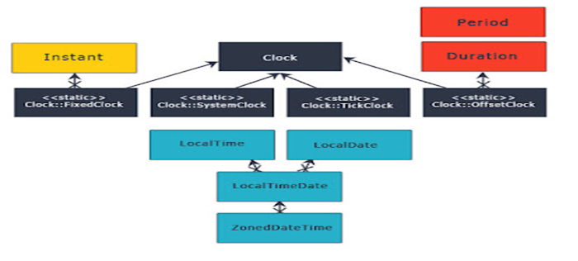

Java.time.LocalDate Class
immutable object
It doesn’t carry any information about the offset or time zone. It stores the date in YYYY-MM-DD format, for example ‘2014-03-18’.

LocalDate.of(2015, 03, 18); -- When individual values know
LocalDate.parse("2015-03-18"); -- Creating from date string

LocalDate.now(); -- To get the current date.
LocalDate.now(ZoneId.of("America/Chicago"));

LocalDate date = LocalDate.now();
date.getMonth();
date.getDayOfYear();
date.get(ChronoField.YEAR);

LocalTime
Similar to LocalDate class, LocalTime represents only time of the day. It also doesn’t hold time zone details. It stores the time in HH:mm:ss.nano_seconds format
LocalTime.of(4, 30, 15);
LocalTime.parse("04:30:15.12345");
LocalTime.now();
LocalTime.now(ZoneId.of("America/Chicago"));
date.getMinute();
date.getNano();
date.get(ChronoField.HOUR_OF_DAY);

LocalDateTime
LocalDateTime is the combination of LocalDate and LocalTime that holds both date and time parts with out time zone details. The format of stored data is 2007-12-03T10:15:30 whete ‘T’ is the delimiter between date and time values.
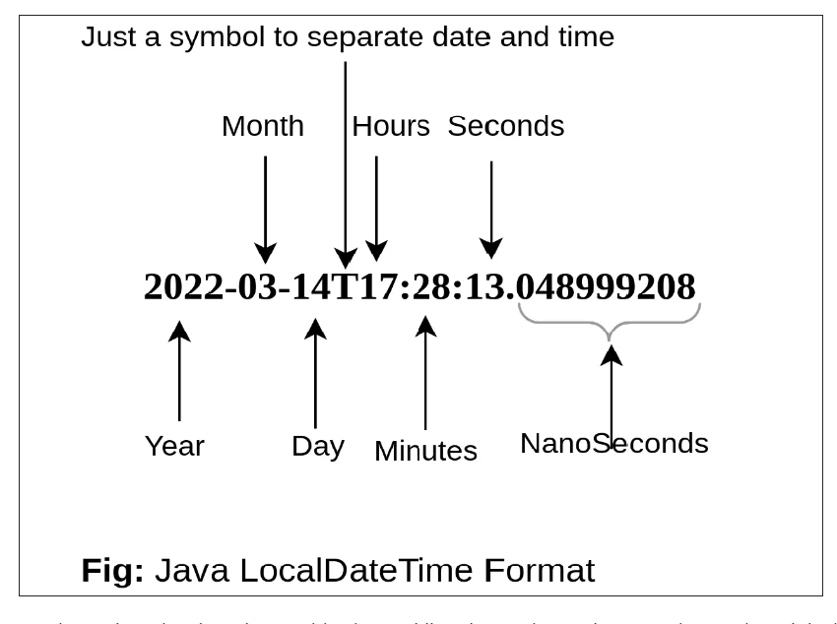
LocalDateTime.now();
LocalDateTime.getDayOfWeek();
LocalDateTime.parse("2007-12-03T10:15:30");

date.toLocalDate();
date.toLocalTime();

Instant
Instant is a point on a continuous time line or scale. Basically this represents the number of seconds passed since the Epoch time 1970-01-01T00:00:00Z. Internally Instant stores two values, one long value representing epoch-seconds and an int representing nanosecond-of-second, which will always be between 0 and 999,999,999. Any date-time after 1970-01-01T00:00:00Z will return positive value and before will be negative value.
1. Instant.now();
2. Instant.now().getEpochSecond();
3. Instant.parse("1969-01-01T00:00:00.00Z").getEpochSecond(); --> -31,536,000
4. Instant.parse("1971-01-01T00:00:00.00Z").getEpochSecond(); --> 31,536,000

DateTimeFormatter: This class is the replacement for java.text.DateFormat which provides two main methods; format(temporal) to convert temporal object to string and parse(string) to create a temporal object from the given date string. Creating DateTimeFormatter instance is easy, it provides overloaded ofpattern methods to create it instances.
DateTimeFormatter f1 = DateTimeFormatter.ofPattern("dd-MMM-yyyy");
LocalDate date = f1.parse("18-Mar-2014");
f1.format(LocalDate.of(2014, 3, 18)); => 18-Mar-2014

//For localization
DateTimeFormatter f2= DateTimeFormatter.ofPattern("dd-MMM-yyyy", Locale.FRENCH);
f2.format(LocalDate.of(2014, 3, 18)); => 18-mars-2014
DateTimeFormatter class also contains many of its own instances like ISO_LOCAL_DATE, ISO_LOCAL_DATE_TIME, BASIC_ISO_DATE etc that can be used for our gene
A temporal field is a field of date-time, such as month-of-year or hour-of-minute. These fields are represented by the TemporalField interface and the ChronoField class implements this interface. The get() or getLong() methods of the class LocaldateTime accepts a temporal field as a parameter and gets the value of the given field in the current object.

LocalDateTime lDate = LocalDateTime.now();
int field = lDate.get(ChronoField.DAY_OF_MONTH);

java.util.Arrays Class
This is a part of the Java Collections framework and provides methods to create, access and manipulate Java arrays dynamically.
All the methods provided by the Arrays class are static in nature.
The Arrays class was introduced in Java 1.2 and the methods it contains are mostly used for manipulation of the array including searching, sorting, etc. The arrays class provides overloaded methods for almost all the data types.
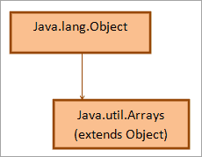 | static< T> List<T>asList(Object[] a)  static int binarySearch (int[] a, int fromIndex, int toIndex, int key)

Arrays class
all methods are static
any primitive datatype array can be navigated
public static int binarySearch(int[],int value) //before search array must be sorted
public static boolean equals(int[],int[]);
public static void fill(int[],int value);
public static void fill(int[],int stindex,int endindex,int value);
public static void sort(int[]);
public static void sort(int[],int stindex,int endindex);
If stindex > end index it raises IllegalArgumentException

INTERVIEW QUESTION:-
Which sorting is used in Arrays class to sort in Java?
Ans: The sort method of Arrays class in Java uses two sorting techniques. It uses quicksort when primitive types are used whereas when objects are used that implement comparable interface, merge sort is used.

SORTING OF ARRAYS:-
- Arrays.sort()
- Collections.sort()
- Comparator interface
- Comparable interface

Arrays.sort(), which is limited to arrays

Collections.sort() can sort all List implementations

The Comparator interface is used to order objects of an arbitrary class. It is not to be confused with the Comparable interface, which is implemented by the class to be sorted. The Comparator interface is implemented in a separate class.
Syntax
class MyComparator implements Comparator<MyClass> {
@Override public int compare(MyClass a, MyClass b)
{
// Compare logic
...
return result;
}
}

The Comparable interface is used to define how a class is to be sorted. It is not to be confused with the Comparator interface, which is implemented in a separate class. The Comparable interface is implemented in the class to be sorted.
Syntax
class MyClass implements Comparable<MyClass> {
// Class body.
...
@Override public int compareTo(MyClass value)
{
// Comparison Logic
...
return result;
}
}

INTERVIEW QUESTION
Differentiate Comparator & Comparable

Java.util. StringTokenizer Class
StringTokenizer class allows you to break a String into tokens. It is simple way to break a String. It is a legacy class of Java.

Note: The StringTokenizer class is deprecated now. It is recommended to use the split() method of the String class or the Pattern class that belongs to the java.util.regex package.

StringTokenizer class
StringTokenizer(String);
StringTokenizer(String,String separators);
public int countTokens();
public boolean hasMoreTokens();
public String nextToken();

Week5 | Java File Handling

variables and arrays are used to store data inside Java programs. This approach creates two problems.
- Data stored in a program is lost when the program is terminated. It means storage is temporary.
- Large volumes of data are difficult to handle using variables and arrays.
To overcome these problems, we use the concept of files to store secondary storage devices called hard.

A file is a collection of related records located in a specific area on the disk

A directory in Java is a file within a file system that contains several files and other directories.
A file system is a hierarchy of files and directories, starting from a root directory.

In Java, with the help of File Class, we can work with files
File Class is inside the java.io package

File class Constructors | File class methods
1. File(String pathName): This constructor creates a File object with the specified pathname. The pathname may be a file or a directory.  It converts the given pathname string into an abstract pathname.  2. File(String directoryPath, String filename): This constructor creates a new File instance from a directory with the specified directory path and filename.  3. File(File dirObject, String filename): This constructor creates a new File instance from a File object dirObject that specifies a directory and a file having the name filename.  4. File(URI uriObj): uriObj is a URI object that describes a file. | 1. boolean exists():  2. boolean canExecute():  3. boolean canRead():  4. boolean canWrite():  5. boolean isAbsolute():  6. boolean isDirectory():  7. boolean isFile():  8. boolean isHidden():  9. boolean createNewFile():  10. boolean delete():

WAP to create the following scenario & perform File operations

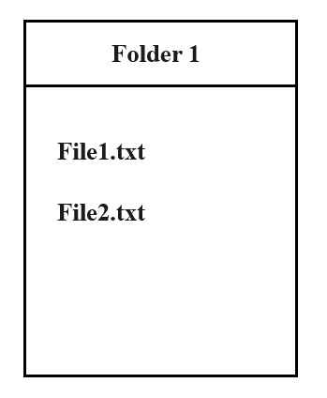
How to set file permissions in java?
File scriptFile = new File("/test.sh");
System.out.println("Current file permissions:");
System.out.println("Can Execute "+scriptFile.canExecute());
System.out.println("Can Read"+scriptFile.canRead());
System.out.println("Can Write"+scriptFile.canWrite());
scriptFile.setExecutable(true);
scriptFile.setReadable(true);
scriptFile.setWritable(true);

Java's IO package mostly concerns itself with the reading of raw data from a source and writing of raw data to a destination. The most typical sources and destinations of data are these:
- Files, Files are a common source or destination of data in Java applications
- Pipes, Pipes in Java IO provides the ability for two threads running in the same JVM to communicate.
- Network Connections, networking API which makes it easy to communicate via TCP/IP sockets or UDP sockets over the internet.
- In-memory Buffers, Byte and char arrays are often used in Java to temporarily store data internally in an application.
- System.in, System.out, System.error, Java has 3 streams commonly used to provide input to, and output from Java applications.

Streams in Java
- In Java, a sequence of data is known as a stream.
- This concept is used to perform I/O operations on a file.
- There are two types of streams :

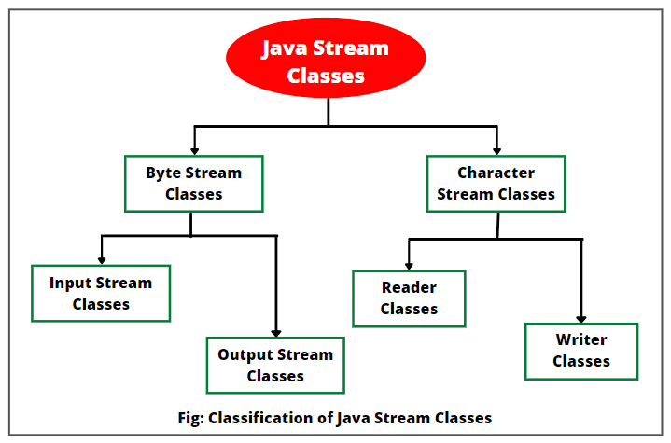

Byte streams | Character streams
Byte streams in Java are designed to provide a convenient way for handling the input and output of bytes (i.e., units of 8-bits data).  Binary files are those files that are machine readable. For example, executable files, image files, and files in low-level file formats such as .zip, .class, .obj, and .exe.  Byte streams that are used for reading are called input streams and for writing are called output streams. They are represented by the abstract classes of InputStream and OutputStream in Java. | Character streams in Java are designed for handling the input and output of characters. They use 16-bit Unicode characters.  Character streams are more efficient than byte streams. They are mainly used for reading or writing to character or text-based I/O such as text files, text documents, XML, and HTML files.  Character streams that are used for reading are called readers and for writing are called writers. They are represented by the abstract classes of Reader and Writer in Java.

Byte streams | Character streams
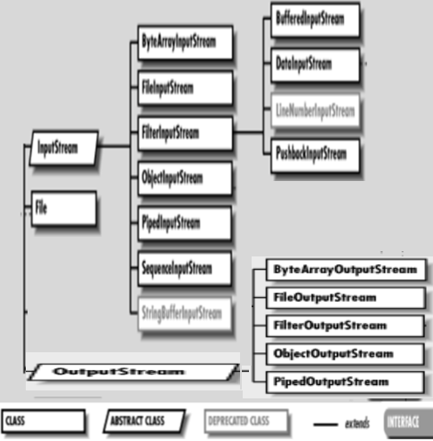 | 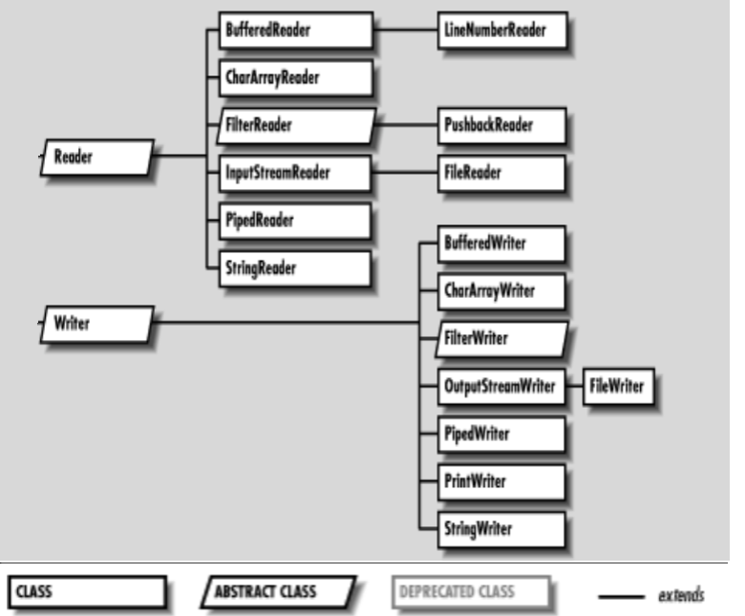
InputStream methods  1. int read(): int value in the range 0 to 255.  end of the stream is reached, the value –1 is returned.  If this method encounters an I/O error, it will throw an IOException.  2. int read(byte[ ] b): reads and stores into the array of bytes b.  3. int read(byte[ ] b, int n, int m): m bytes of data from nth byte into an array b.  4. int available(): returns an estimate of the number of bytes that can be read  5. void close(): The close() method closes the input stream and releases any system resources associated with it.  6. long skip(long n): This method skips over n bytes of data from this input stream.  7. void reset(): The reset() method is used to go back to the beginning of the stream.  OutputStream methods  1. void write(int b): The write() method writes the specified byte to the output stream. It accepts an int value as an input parameter. It throws an IOException if an I/O error occurs (e.g. output stream has been closed).  2. void write(byte[ ] b): This method writes all the specified bytes in the array b to the output stream.  3. void write(byte[ ] b, int n, int m): It writes m bytes from array b starting from nth byte to the output stream.  4. void close(): It closes the output stream and releases any system resources associated with this stream.  5. void flush(): It flushes the output stream and forces any buffered output bytes to be written out. | Reader class methods  1.int read()It reads the next character from the input stream.  2. int read(char[] cbuffer)It reads a chunk of charaters from the input stream and store them in its byte array, cbuffer.  3. int read(char[] cbuf, int off, int len)It reads charaters into a portion of an array.  4. int read(CharBuffer target)It reads charaters into the specified character buffer.  5. String readLine()It reads a line of text. A line is considered to be terminated by any one of a line feed ('\n'), a carriage return ('\r'), or a carriage return followed immediately by a linefeed.  6. boolean ready()It tells whether the stream is ready to be read.  7. void close()It closes the input stream and also frees any resources connected with this input stream.  Writer class methods  1.void flush()It flushes the output steam by forcing out buffered bytes to be written out.  2.void write(char[] cbuf)It writes a whole array(cbuf) to the output stream.  3.void write(char[] cbuf, int off, int len)It writes a portion of an array of characters.  4.void write(int c)It writes single character.  5.void write(String str)It writes a string.  6.void write(String str, int off, int len)It writes a portion of a string.  7.Writer append(char c)It appends the specified character to the writer.  8.Writer append(CharSequence csq)It appends the specified character sequence to the writer  9.Writer append(CharSequence csq, int start, int end)It appends a subsequence of the specified character sequence to the writer.  10.void close()It closes the output stream and also frees any resources connected with this output stream.

ByteArrayInputStream class can turn a byte array into an InputStream.
ByteArrayOutputStream

FilterInputStream no special behaviour,It’s a base class for subclasses
FilterOutputStream

ObjectInputStream enables to read Java objects from an InputStream instead of raw bytes.
ObjectOutputStream

Pipes are communication channels between threads inside the same JVM.

PipedInputStream to read the contents of a pipe as a stream of bytes.
PipedInputStream

SequenceInputStream combines two or more other InputStream's into one.

StringBufferInputStream an input stream in which the bytes read from buffered string.
StringBufferOutputStream

FileInputStream, makes it possible to read the contents of a file as a stream of bytes.
FileOutputStream

BufferedInputStream reads chunks of bytes and buffering for a Java InputStream.
BufferedOutputStream

DataInputStream enables to read Java primitives from an InputStream instead of raw bytes.
DataOutputStream

PushbackInputStream is intended to be used when you parse data from an InputStream. Sometimes you need to read ahead a few bytes to see what is coming, before you can determine how to interpret the current byte.

InputStreamReader interprets the bytes of an InputStream as text instead of numeric data.
OutputStreamReader

CharArrayReader enables you to read the contents of a char array as a character stream.
CharArrayWritter

FileReader class, makes it possible to read the contents of a file as a stream of characters.
FileWritter

PipedReader class makes it possible to read the contents of a pipe as a stream of characters
PipedWritter

BufferedReader, provides buffering for your Java Reader instances. Buffering can speed up IO quite a bit. Rather than read one character at a time from the underlying Reader, the Java BufferedReader reads a larger block (array) at a time. This is typically much faster, especially for disk access and larger data amounts.
BufferedWritter

FilterReader is a base class for implementing your own filtering readers.
FilterWritter

StringReader class enables you to turn an ordinary String into a Reader.
StringReader

PushbackReader is intended to be used when you parse data from a Reader. Sometimes you need to read ahead a few characters to see what is coming, before you can determine how to interpret the current character

LineNumberReader is a BufferedReader that keeps track of line numbers of the read characters. Line numbering begins at 0. Whenever the LineNumberReader encounters a line terminator in the characters returned by the wrapped Reader, the line number is incremented.

The exception classes in the java.io package
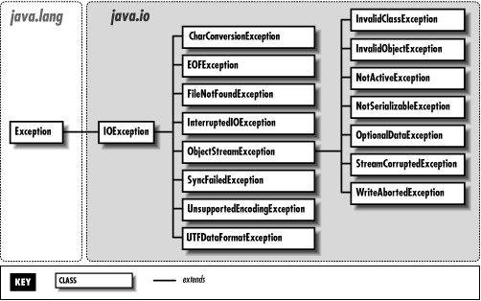
INTERVIEW QUESTIONS:
Q.What is the difference between Serializable and Externalizable interface in Java?
Serializable interface exists in java.io package and forms core of java serialization mechanism. It doesn't have any method and also called Marker Interface in Java. When your class implements java.io.Serializable interface it becomes Serializable in Java and gives compiler an indication that use Java Serialization mechanism to serialize this object.
Externalizable provides us writeExternal() and readExternal() method which gives us flexibility to control java serialization mechanism instead of relying on Java's default serialization.

Q.While serializing you want some of the members not to serialize? How do you achieve it?
If you don't want any field to be part of object's state then declare it either static or transient based on your need and it will not be included during Java serialization process.
Can we transfer a Serialized object vie network?
Yes you can transfer a Serialized object via network because java serialized object remains in form of bytes which can be transmitter via network. You can also store serialized object in Disk or database as Blob.

Q.What is RandomAccessFile?
It is a special class from java.io package which is neither a input stream nor a output stream (because it can do both). It is directly a subclass of Object class. Generally, a stream does only one purpose of either reading or writing; but RandomAccessFile can do both reading from a file and writing to a file. All the methods of DataInputStream and DataOutStream exist in RandomAccessFile.

Q. Tell something about BufferedWriter ? What are flush() and close() used for ?
Ans. A Buffer is a temporary storage area for data. The BufferedWriter class is an output stream.It is an abstract class that creates a buffered character-output stream.
Flush() is used to clear all the data characters stored in the buffer and clear the buffer.
Close() is used to closes the character output stream.

Q. What is Scanner class used for ? when was it introduced in Java ?
Ans. Scanner class introduced in Java 1.5 for reading Data Stream from the imput device. Previously we used to write code to read a input using DataInputStream. After reading the stream , we can convert into respective data type using in.next() as String ,in.nextInt() as integer, in.nextDouble() as Double etc

RandomAccessFile
RandomAccessFile(String path,String mode)
modes :
"r" , "rw"

public long getFilePointer()
public void skipBytes(long n)
public void seek(long n) moves the cursor position to the specified byte

The RandomAccessFile class in Java serves as a powerful tool for performing both read and write operations at any position within a file. Unlike other file access classes in Java like FileInputStream and FileOutputStream, which allow sequential access to files, RandomAccessFile allows direct access to any part of the file's contents.

Java RandomAccessFile provides the facility to read and write data to a file. RandomAccessFile works with file as large array of bytes stored in the file system and a cursor using which we can move the file pointer position.

RandomAccessFile class is part of Java IO. While creating the instance of RandomAccessFile in java, we need to provide the mode to open the file.
- If the mode (in string) is “r”, the file can be read-only, but not written.
- If it is “rw”, the file is opened in read-write mode.
- If it is “rws”, the file is opened for read-write and every change to the file’s data will be immediately written to the physical device.
- “rwd”: same as “rw”, plus any changes to the file’s content, but not its metadata take effect immediately.

To get the current file pointer, you can call getFilePointer() method and to set the file pointer index, you can call seek(int position) method moves the file pointer to a specified location.

RandomAccessFile raf = new RandomAccessFile("file.txt", "r");  raf.seek(1);  byte[] bytes = new byte[5];  raf.read(bytes);  raf.close();  System.out.println(new String(bytes)); | In the first line, we are creating RandomAccessFile instance for the file in read-only mode. Then in the second line, we are moving the file pointer to index 1. We have created a byte array of length 5, so when we are calling read(bytes) method, then 5 bytes are read from file to the byte array. Finally, we are closing the RandomAccessFile resource and printing the byte array to console.

Week6 | Exception Handling, Java Concurency and Multithreading

When executing Java code, different errors can occur in which Java program will normally stop and generate an error message (i.e, exception ).

Error | Exception
Error is an fatal & irrecoverable event that cannot be handled at runtime.  Ex:OutOfMemoryError, StackOverflowError. | Exception is an non-fatal & recoverable event that can be handled at runtime.  Ex:IOException, NullPointerException

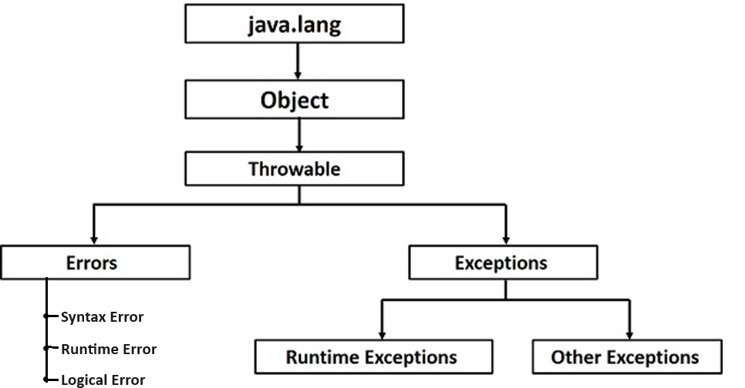

The Exception Handling in Java is one of the powerful mechanism to handle the runtime errors so that the normal flow of the application can be maintained.

Without Exception Hndling | With Exception Handling
public class ExceptionDemo {  private static String inputString = "123.33";  public static void main(String[] args) {  int a = Integer.parseInt(inputString);  }  }  Output:  Exception in thread “main”: java.lang.NumberFormatException:null  Note:-program terminates abnormally. | public class ExceptionDemo {  private static String inputString = "123.33";  public static void main(String[] args) {  try {  int a = Integer.parseInt(inputString);  }catch(NumberFormatException ex){  System.err.println("Invalid string in argumment"); }  }  }  Output: Invalid string in argumment

The try statement allows you to define a block of code to be tested
The catch statement allows you to define a block of code to be executed, if an error

INTERVIEW QUESTION
Rules for writing try and catch blocks:
Rule1:try block must be followed by catch block | Rule2:try block can have multiple catch blocks | Rule3:finally block must be last block after try-catch blocks
try {  // Block of code to try  } catch(Exception e) {  // catch block1  } | try {  // Block of code to try  }catch(Exception e) {  // catch block1  } catch(Exception e) {  // catch block2  } | try {  // Block of code to try  }catch(Exception e1) {  // catch block1  } catch(Exception e2) {  // catch block2  }finally {  // Optional: Code that will be executed regardless of whether an exception occurred or not  }

Rule4: For each try block there can be 0 or more catch blocks, but only one finally block.
try {  // Block of code to try  }catch(Exception e1) {  // catch block1  } catch(Exception e2) {  // catch block2  }finally {  // Code that will be executed regardless of whether an exception occurred or not  } | try {  // Block of code to try  }finally {  // Code that will be executed regardless of whether an exception occurred or not  }

INTERVIEW QUESTION
Q. Differentiate throw & throws
throw | throws
Keyword used to throw the Exception explicitly. | If Exception is not handled then “throws” Keyword used for propagating the Excepttion to the next level

INTERVIEW QUESTION

Q. final vs finally vs finalize in Java
final | finally | finalize
final (lowercase) is a reserved keyword in java  final with Variables: The value of the variable cannot be changed once initialized.  final with Class: The class cannot be inherited  final with Method: The method cannot be overridden by a subclass. | Finally is a reserved keyword in java  A finally block of code is always executed whether an exception has occurred or not. | Finalize is a method in java  The finalize method in java is called by the garbage collector before an object is garbage collected. This method can be used to perform any necessary cleanup before the object is destroyed,

USER DEFINED EXCEPTION
In Java, a user defined exception is a powerful tool for dealing with specific requirements and scenarios. They enable programmers to provide more descriptive error messages and manage exceptions more effectively and efficiently.
In order to create custom exception, we need to extend Exception class that belongs to java.lang package.
To implement a user-defined exception in Java, follow these steps:
- Create a custom exception class that extends the base exception class (java.lang.Exception).
- Define the constructor for the custom exception class. The constructor can accept parameters to provide more information about the error.
- Override the toString() method to provide a custom error message.
- Use the "throw" keyword to throw an instance of the custom exception when the error condition occurs.
- Use a "try-catch" block to catch the exception and handle it appropriately.

CHECKED vs UNCHECKED EXCEPTIONS
CHECKED EXCEPTIONS | UNCHECKED EXCEPTIONS
In Java, checked exceptions are exceptions that the Java compiler checks for and requires you to handle or declare in your code. Checked exceptions are typically used to indicate a recoverable error, such as when a file cannot be found or a network connection cannot be established.  Java compiler raises a compile-time error if a checked exception is left unhandled or undeclared.  Example:-  IO Exception  SQL Exception  Interrupted Exception | In Java, unchecked exceptions are exceptions that the Java compiler does not enforce checking for. These exceptions are usually associated with runtime errors that occur when a program violates an assumption about the system’s state, such as going beyond the bounds of an array or encountering a null pointer  Example:-  NullPointer Exception  Arithmetic Exception  Array Index Out Of Bounds Exception
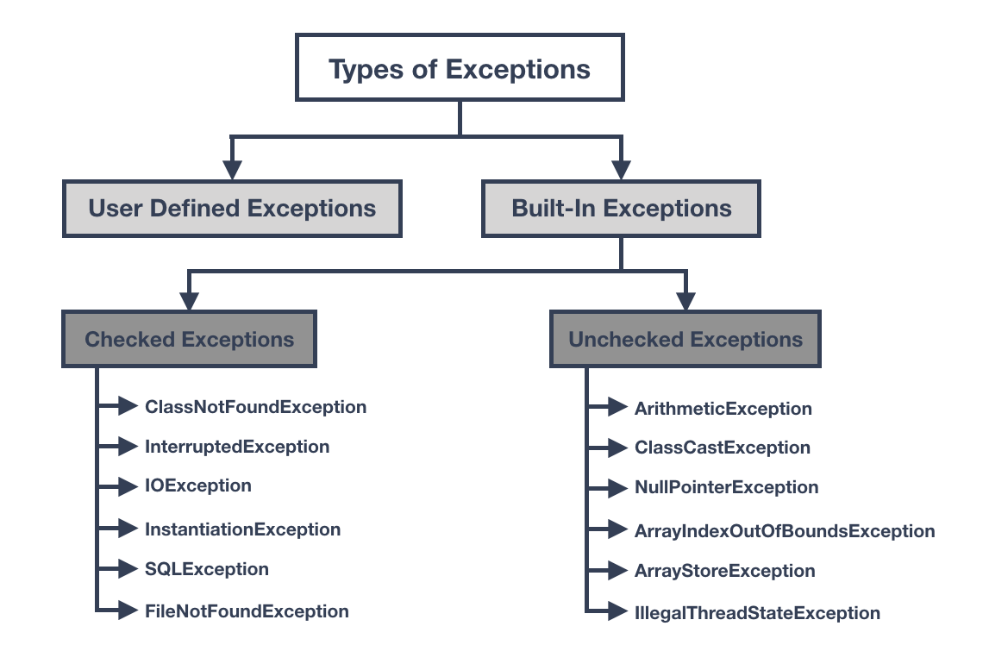

Feature | Checked Exceptions | Unchecked Exceptions
Definition | Exceptions that must be either caught or declared in the method signature. | Exceptions that do not need to be handled.
Use case | For conditions that can be reasonably recovered from. | For conditions that cannot be recovered from, such as programming errors.
Propagation | Must be either caught or declared in the method signature. | Can be propagated up the call stack without being caught.
Coding overhead | More coding overhead due to the requirement to handle or declare exceptions. | Less coding overhead, since exceptions do not need to be handled.
Example | FileNotFoundException, IOException, SQLException. | NullPointerException, ArrayIndexOutOfBoundsException, IllegalArgumentException.
Syntax | Must be surrounded by a try-catch block or declared in the method signature. | Do not need to be surrounded by a try-catch block

INTERVIEW QUESTIONS
Q. What is the difference between checked and unchecked exceptions in Java?
Checked exceptions in Java are exceptions that must be explicitly caught or declared in the method that throws them, whereas unchecked exceptions do not. Unless they are derived from the base unchecked exception class (java.lang.RuntimeException), user-defined exceptions are typically treated as checked exceptions.

Q.Differentiate between Checked Exception and Unchecked Exceptions in Java.
The followings programs are the differences between Checked and Unchecked Exceptions:
Checked Exceptions | Unchecked Exceptions
These exceptions are checked and handled at the time of compilation. | These Exceptions are not checked and handled at compilation time. They occur during the runtime of the program and can not be anticipated by the compiler.
These exceptions are a direct subclass of the Exception class. | These exceptions are a direct subclass of the RuntimeException class.
Program would give compilation error if checked exceptions are not handled. | Program compiles successfully, but the exception could occur at runtime due to logical errors in the program.
Checked Exceptions require handling using a try-catch block or at least the method should use the throws keyword to let the calling method know that a checked exception could be thrown from this method. | Unchecked Exceptions do not require try-catch or throws handling. These exceptions could occur due to mistakes in programming logic.
Examples: IOException, FileNotFoundException, DataAccessException, InterruptedException, etc. | Examples: ArithmeticException, ArrayIndexOutOfBoundException, NullPointerException, InvalidClassException, etc.

Q. Can you catch and handle Multiple Exceptions in Java?
There are three ways to handle multiple exceptions in Java:
Since Exception is the base class for all exception types, make use of a catch block that catches the Exception class-
try {
// do something
} catch (Exception exception) {
// handle exception
}
However, it is recommended to use accurate Exception handlers instead of generic ones. This is because having broad exception handlers could make the code error-prone by catching exceptions that were not anticipated in the software design and could result in unexpected behavior.
From Java 7 onwards, it is now possible to implement multiple catch blocks as shown below -
try {
// do something
} catch (FileNotFoundException fileNotFoundException) {
// handle FileNotFoundException
} catch (EOFException eofException) {
// handle EOFException
}
When we are using multiple catch blocks, we need to ensure that in a case where the exceptions have an inheritance relationship, the child exception type should be the first and the parent type later to avoid a compilation error.
Java 7 also began to provide the usage of multi-catch blocks for reducing duplication of code if the exception handling logic was similar for different exception types. The syntax of the multi-catch block is as shown below-
try {
// ...
} catch (FileNotFoundException | EOFException exception) {
// ...
}

Q. What is a stack trace and how is it related to an Exception?
A stack trace is information consisting of names of classes and methods that were invoked right from the start of program execution to the point where an exception occurred. This is useful to debug where exactly the exception occurred and due to what reasons. Consider an example stack trace in Java,
Exception in thread "main" java.lang.NullPointerException
at com.example.demoProject.Book.getBookTitle(Book.java:26)
at com.example.demoProject.Author.getBookTitlesOfAuthor(Author.java:15)
at com.example.demoProject.DemoClass.main(DemoClass.java:14)
To determine where an exception has occurred, we need to check for the beginning of the trace that has a list of “at …”. In the given example, the exception has occurred at Line Number 26 of the Book.java class in the getBookTitle() method. We can look at this stack trace and go to the method and the line number mentioned in the trace and debug for what could have caused the NullPointerException. Furthermore, we can get to know that the getBookTitle() method in the Book.java class was called by the getBookTitlesOfAuthor() method in the Author.java class in Line Number 15 of the file and this in turn was called by the main() method of the DemoClass.java file in Line Number 14.

Q. What is Exception Chaining?
Exception Chaining happens when one exception is thrown due to another exception. This helps developers to identify under what situation an Exception was thrown that in turn caused another Exception in the program. For example, we have a method that reads two numbers and then divides them. The method throws ArithmeticException when we divide a number by zero. While retrieving the denominator number from the array, there might have been an IOException that prompted to return of the number as 0 that resulted in ArithmeticException. The original root cause in this scenario was the IOException. The method caller would not know this case and they assume the exception was due to dividing a number by 0. Chained Exceptions are very useful in such cases. This was introduced in JDK 1.4.

Java Concurency and Multithreading
A thread of execution is the smallest unit of processing that can be scheduled by an operating system.
Thread | Process
- Threads are lightweight since they run in a shared memory space | - Process are Heavyweight since they run in a separate memory spaces
- Context switching between threads is usually less expensive | - Context switching between processes is more expensive
- Cost of thread intercommunication is low | - Cost of process intercommunication is high

A Java Thread is like a virtual CPU that can execute your Java code - inside your Java application. when a Java application is started its main() method is executed by the main thread - a special thread that is created by the Java VM to run your application. From inside your application you can create and start more threads which can execute parts of your application code in parallel with the main thread.

Java threads are objects like any other Java objects. Threads are instances of class java.lang.Thread, or instances of subclasses of this class. In addition to being objects, java threads can also execute code.

Creating a Thread

1)Thread Subclass

public class MyThread extends Thread {

public void run(){

System.out.println("MyThread running");

}

}

MyThread myThread = new MyThread();

myTread.start();

2) Runnable Interface Implementation

There are three ways to implement the Runnable interface:

- Create a Java class that implements the Runnable interface.
public class MyRunnable implements Runnable {
public void run(){
System.out.println("MyRunnable running");
}
}
Thread thread = new Thread(new MyRunnable());
thread.start();

- Create an anonymous class that implements the Runnable interface.
Runnable myRunnable =
new Runnable(){
public void run(){
System.out.println("Runnable running");
}
}

Thread thread = new Thread(myRunnable);
thread.start();

- Create a Java Lambda that implements the Runnable interface.

Runnable runnable = () ->

{ System.out.println("Lambda

Runnable running"); };

Thread thread = new Thread(runnable);

thread.start();

Thread States in Java

A thread is a path of execution in a program that enters any one of the following five states during its life cycle. The five states are as follows:
- New
- Runnable
- Running
- Blocked (Non-runnable state)
- Dead (terminated)

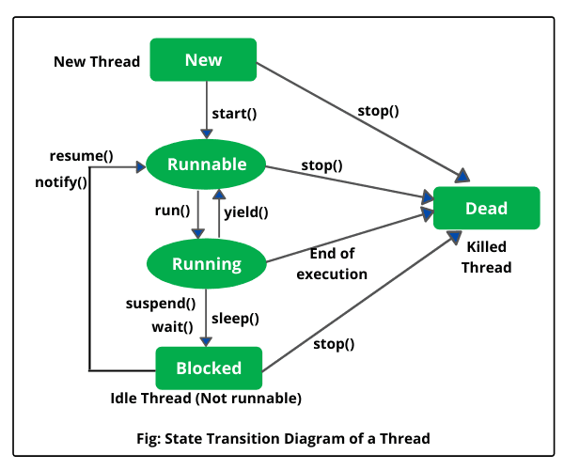

When we create a thread object using the Thread class, the thread is born and enters the New state. In this state, the Thread object exists but it cannot execute any statement because the execution of thread has not started. Only after calling the start() method does the thread move to the Runnable state.

NOTE:- Only start() method can be called on a new thread. If any method other than start() is called while the thread is still in the NEW state, an IllegalThreadStateException will be thrown.

In runnable state, the thread is either running or ready to run and is waiting for the availability of the processor (CPU time) for execution of code.

Running means Processor (CPU) has allocated time slot to thread for its execution.

A running thread may give up its control in any one of the following situations and can enter into the blocked state.
a) When sleep() method is invoked on a thread to sleep for specified
time period, the thread is out of queue during this time period. The
thread again reenters into the runnable state as soon as this time
period is elapsed.
b) When a thread is suspended using suspend() method for some time
in order to satisfy some conditions. A suspended thread can be
revived by using resume() method.
c) When wait() method is called on a thread to wait for some time. The
thread in wait state can be run again using notify() or notifyAll()
method.

Thread API
java.lang.Thread class
\
public static Thread currentThread()
public String getName()
public void setName(String )
public static void sleep(int ms) throws InterruptedException

Thread()
Thread(String tname)
Thread(Object obj,String tname);
|
it represents the location of run method

public void start();
public void run();
public boolean isAlive()
public void join() throws InterruptedException

>>>> thread priorities
MIN_PRIORITY 1
NORM_PRIORITY 5
MAX_PRIORITY 10
public void setPriority(int);
public int getPriority();

Examples:-
public class demo1
{
public static void main(String args[])
{ Thread t1=Thread.currentThread();
System.out.println(t1);
System.out.println(t1.getName());
t1.setName("demothread");
System.out.println(t1);
for(int i=1;i<=5;i++)
{
System.out.println("welcome to JAVA");
try{
Thread.sleep(3000);
}catch(InterruptedException e)
{
System.out.println(e);
}
}
}
}
public class demo2
{
public static void main(String args[])
{
ourthread o1=new ourthread();
for(int i=1;i<=200;i++)
System.out.println("main :"+i);
}
}
class ourthread extends Thread
{
public ourthread()
{
super("child");
start();
}
public void run()
{
for(int i=1;i<=200;i++)
System.out.println(getName()+" : "+i);
}
}

start() | run()
1. start() Method:  - Used to start a new thread.  - Internally calls the run() method of the thread.  - Creates a new thread and executes run() inside it.  - Runs in parallel with the main thread.  - Cannot be called more than once on the same thread object (throws IllegalThreadStateException). | 2. run() Method:  - Acts like a normal method, not a separate thread.  - If called directly, it runs in the same thread (no multithreading).  - Does not create a new thread.

wait() | join()
wait() Method  - Defined In: Object class.  - Usage: Causes the current thread to wait until another thread calls notify() or notifyAll() on the same object.  - Synchronization Required: Must be called within a synchronized block/method (synchronized keyword is mandatory).  - Purpose: Used for inter-thread communication (e.g., producer-consumer problems). | join() Method  - Defined In: Thread class.  - Usage: Causes the current thread to wait until the specified thread (join() is called on) finishes execution.  - Synchronization Not Required: Does not require a synchronized block.  - Purpose: Used to ensure that a thread completes its execution before proceeding further.

notify() | yield()
notify() Method  - Defined In: Object class.  - Usage: Wakes up a single thread that is waiting on the object's monitor (previously called wait()).  - Synchronization Required: Must be called inside a synchronized block/method.  - Effect: Notifies one waiting thread to resume execution, but the actual execution depends on thread scheduling.  - Purpose: Used for inter-thread communication, often with wait() in producer-consumer problems. | yield() Method  - Defined In: Thread class.  - Usage: Suggests to the scheduler that the current thread is willing to give up the CPU to other threads of equal or higher priority.  - Synchronization Not Required: Can be called from anywhere.  - Effect: Moves the current thread back to the ready/runnable state, but the thread may continue if no other thread is eligible.  - Purpose: Used to improve CPU scheduling fairness, but its behavior depends on the OS and JVM

Java Synchronization
Synchronization in Java is a mechanism that ensures that multiple threads can safely access shared resources without causing race conditions or data inconsistency. It is mainly used in multithreading to control the execution of critical sections.
Synchronized Methods
In Java, you can declare entire methods as synchronized which prevent multiple threads from accessing the method simultaneously. With this, synchronization becomes a simpler process because the mechanism is applied to all invocations of the synchronized method automatically.
public class Counter {
private int count = 0;

public synchronized void increment() {
count++;
}

public int getCount() {
return count;
}

public static void main(String[] args) {
Counter counter = new Counter();

// Create multiple threads to increment the counter
Thread t1 = new Thread(() -> counter.increment());
Thread t2 = new Thread(() -> counter.increment());

t1.start();
t2.start();

try {
t1.join();
t2.join();
} catch (InterruptedException e) {
e.printStackTrace();
}

System.out.println("Final count: " + counter.getCount());
}
}
Synchronized Blocks
Synchronized block provides exclusive access to shared resources, and only one thread is allowed to execute it in the same time frame. It's structured as follows:
- synchronized (object) {
- // Synchronized code block
- }
This monitor object or lock is the subject. While only one thread can be holding a lock on a monitor object at one instance. Other threads that want to go into the synchronized blocks with this object must wait till the lock becomes available.
public class SynchronizedBlockExample {
private final Object lock = new Object();
private int count = 0;

public void increment() {
synchronized (lock) {
count++;
}
}

public int getCount() {
return count;
}

public static void main(String[] args) {
SynchronizedBlockExample example = new SynchronizedBlockExample();

// Create multiple threads to increment the counter
Thread t1 = new Thread(() -> example.increment());
Thread t2 = new Thread(() -> example.increment());

t1.start();
t2.start();

try {
t1.join();
t2.join();
} catch (InterruptedException e) {
e.printStackTrace();
}

System.out.println("Final count: " + example.getCount());
}
}

Best Practices
- Minimize Synchronized Code: Keep synchronized blocks as short as possible to reduce contention and improve performance.
- Use Final Objects: When using synchronized blocks, use final objects as locks to ensure consistency.
- Avoid Nested Synchronization: Nested synchronized blocks can lead to deadlocks. Avoid them or use them with caution.
- Use Concurrent Collections: For complex synchronization, consider using concurrent collections from the java.util.concurrent package, such as ConcurrentHashMap, which provide built-in synchronization.
- Volatile Keyword: For variables that are accessed by multiple threads but do not require complex synchronization, consider using the volatile keyword to ensure visibility.

private volatile boolean flag;
- Thread Safety: Always ensure that shared resources are properly synchronized to maintain thread safety and avoid data corruption.
- Synchronized Static Methods: Synchronize static methods to enforce synchronized access at the class level, ensuring only one thread can execute the static method across all instances.

public static synchronized void staticMethod() {
// method code
}
- Reentrancy: Java's intrinsic locks are reentrant, meaning if a thread holds a lock, it can acquire it again without deadlocking itself.

Week7&8 | Collections

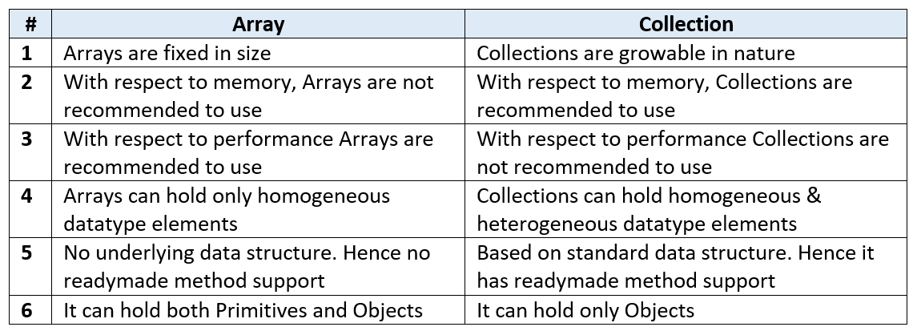
Ex:- Student[] s= new Student[100];
To overcome above problems of Array, we should go for “Collection” concept
The Collection in Java is a framework that provides an architecture to store and manipulate the group of objects.
Operations that can be performed on java collection are searching, sorting, insertion, manipulation, and deletion.
Java Collection framework provides many interfaces (Set, List, Queue, Deque) and classes (ArrayList, Vector, LinkedList, PriorityQueue, HashSet, LinkedHashSet, TreeSet).

Legacy Class in Java
In the past decade, the Collection framework didn't include in Java. In the early version of Java, we have several classes and interfaces which allow us to store objects. So, classes and interfaces that formed the collections framework in the older version of Java are known as Legacy classes.
All the legacy classes are synchronized. The java.util package defines the following legacy classes:
- Dictionary
- HashTable
- Stack
- Properties
- Vector
Dictionary:-
Java Dictionary class is an abstract class.  Java Dictionary class that stores data in key-value pairs  Following are methods of the Dictionary class & all are abstract methods.  - put(K key, V value)  - keys()  - isEmpty()  - get(Object key)  - elements()  - size()  - remove() | 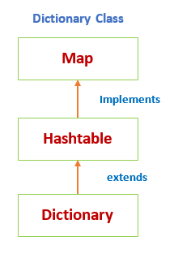

To create a dictionary in Java is to choose a class that implements a “key-value pair” interface.
Dictionary direct subclass is the Hashtable class
INTERVIEW QUESTION:-
Like HashMap HashTableis also unordered.
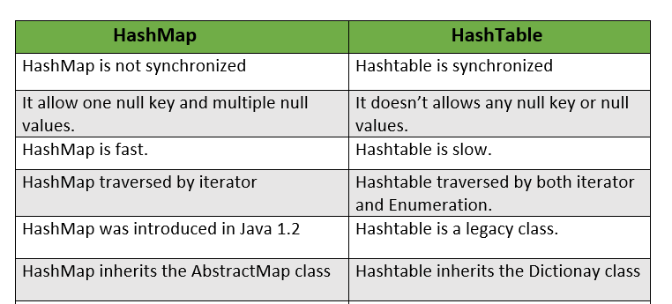
Example:-
Dictionary dict = new Hashtable();
dict.put("101", "ramesh");
dict.put("102", "madhav");s
for (Enumeration e = dict.elements(); e.hasMoreElements();)
{
System.out.println("Values in dictionary : " + e.nextElement());
}

Properties Class:-

The Properties class represents a persistent set of properties.
Properties is a subclass of Hashtable.
It is used to maintain a list of values in which the key and value are both strings.
It is utilized to store data that is to be changed frequently. And changes in properties file needs no recompilation.

Example:-
// create a reader object on the properties file
FileReader reader = new FileReader("db.properties");

// create properties object
Properties p = new Properties();

// Add a wrapper around reader object
p.load(reader);

// access properties data
System.out.println(p.getProperty("username"));
System.out.println(p.getProperty("password"));

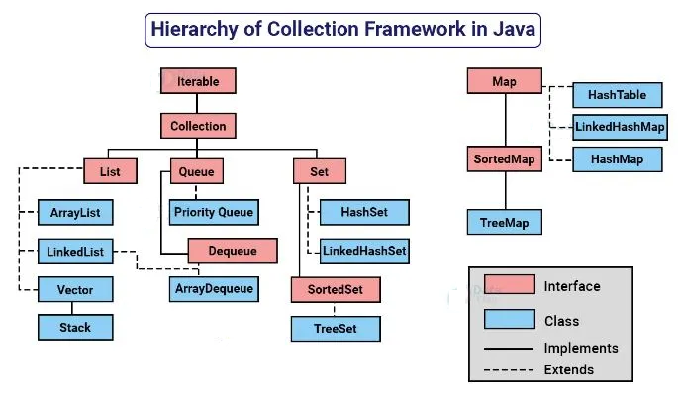
NOTE:-Legacy classes are iterated by using enumerator interface where as java collection frameworkclasses are iterated by using iterator interface

Iteratable interface
The Iterable interface is present in java.lang.Iterable package. It was introduced in JDK 1.5. It allows users to iterate through elements sequentially from a collection.
The Collection framework extends the Iterable interface, thus all the classes implementing the collections framework also implement the Iterable interface. Thus, objects of these classes can use the Iterable feature of Java.
Any class that implements an Iterable interface, overrides the iterator() method present in the Iterable interface. This iterator() method calls an Iterator interface which then returns an iterator. This iterator is used to iterate over an object of that class.  The Iterator interface has 4 methods namely  next(),  hasNext(),  remove() and  forEachRemaining(). | 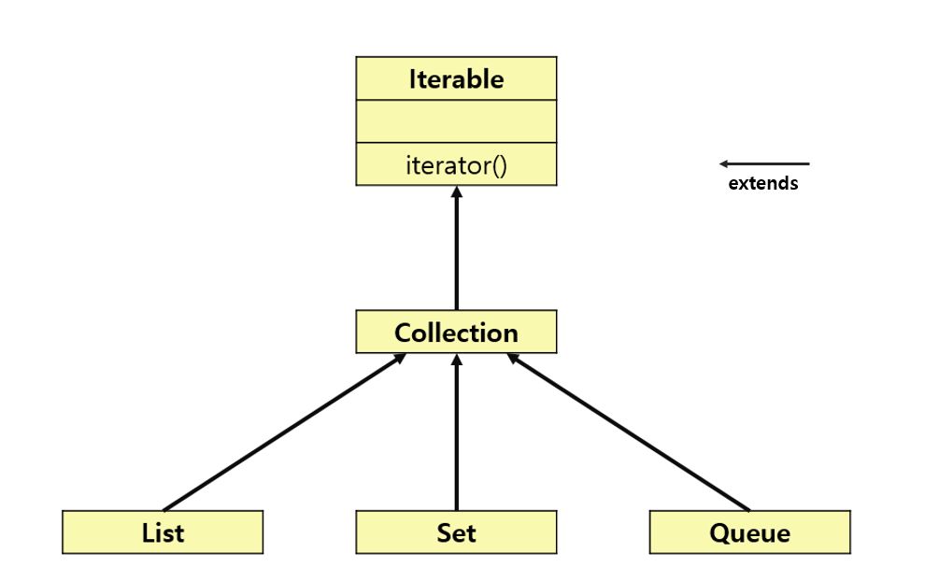
INTERVIEW QUESTION:-
Diiference between iterator and iteratable
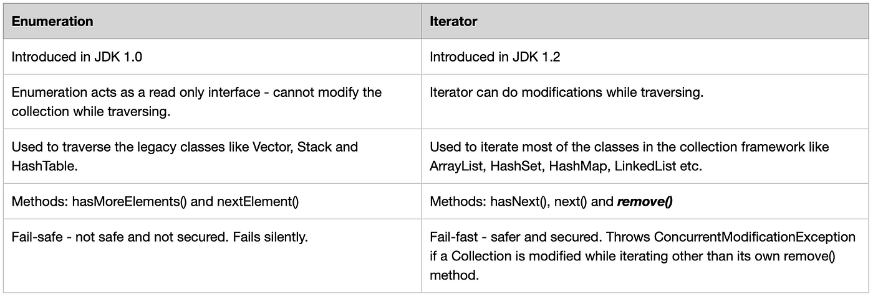
Collection interface
- root interface of Collection Framework
- defines the most common methods which are applicable for any collection object.
add​(E e)
addAll​()
toArray()
size()
containsAll​(Collection<?> c)
equals​(Object o)
hashCode()
isEmpty()
iterator()
parallelStream()
remove​(Object o)
removeAll​(Collection<?> c)
INTERVIEW QUESTION:-
What is the difference between Collection & Collections ❓
“Collection” is an interface. If we want to represent a group of individual objects as a single entity, then we should go for Collection.
“Collections” is an utility class present in java.util package to define several utility methods for Collection objects (like sorting, searching, etc). It defines several utility methods like sorting and searching which is used to operate on collection.
Ex:-
List<Integer> list = new ArrayList<Integer>();
list.add(4);
list.add(5);
list.add(7);
list.add(8);
list.add(2)
Collections.sort(list);
OUTPUT:-
[4, 5, 7, 8, 2]
[2, 4, 5, 7, 8]

INTERVIEW QUESTION:-
Differentiate List , Set, Map
LIST | SET | MAP
-Allows both Heterogenious & Homogenious data  -Duplicates are allowed  -Multiple nulls allowed  -Insertion order is maintained | -Allows both Heterogenious & Homogenious data  -No Duplicates  -One null allowed  -Does not maintain the order of insertion, it is based on the hash code of the values, the order is confirmed. | -Allows both Heterogenious & Homogenious data  -No Duplicates for keys  -One null for keys & multiple nulls allowed form values  -Does not maintain the order

INTERVIEW QUESTION:-
Differentiate Enumerator, Iterator and ListIterator
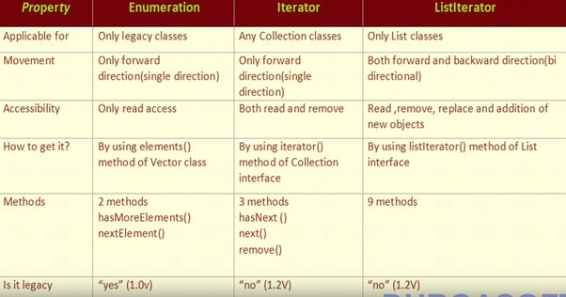
Major Implementations
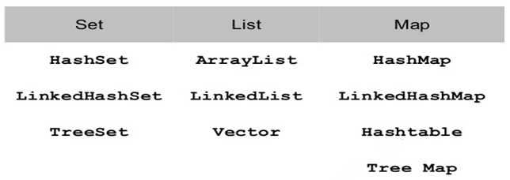
INTERVIEW QUESTION:-
How to implement collection ordering?
One of the most ways to sort list data in Java is to use the Collections.sort() method. It sorts a list in ascending order by default.
List<Integer> numbers = new ArrayList<Integer>();
numbers.add(3);
numbers.add(1);
numbers.add(4);
numbers.add(2);
Collections.sort(numbers);

[OR]

Another way to do this, you will need to create a comparator and pass it as an argument to the Collections.sort() method.

A comparator is an object that implements the java.util.Comparator interface. It has a single method called compare() that compares two objects and returns an integer indicating their relative order.
Class person{
private String name;
private int age;
public Person(String name, int age) {
this.name = name;
this.age = age;
}

class PersonComparator implements Comparator<Person> {
public int compare(Person a, Person b) {
return a.getAge() - b.getAge();
}
}
List<Person> people = new ArrayList<>();
people.add(new Person("Alice", 25));
people.add(new Person("Bob", 30));
people.add(new Person("Charlie", 20));
Collections.sort(people, new PersonComparator());
System.out.println("Sorted List: " + people);
[OR]
Comparable interface is used to order the objects of the String, wrappers & user-defined class. It provides a single sorting sequence only, i.e., you can sort the elements on the basis of single data member only.
public int compareTo(Object obj): It is used to compare the current object with the specified object. It returns
- positive integer, if the current object is greater than the specified object.
- negative integer, if the current object is less than the specified object.
- zero, if the current object is equal to the specified object.
class Student implements Comparable<Student>{
int rollno;
String name;
int age;
Student(int rollno,String name,int age){
this.rollno=rollno;
this.name=name;
this.age=age;
}

public int compareTo(Student st){
if(age==st.age)
return 0;
else if(age>st.age)
return 1;
else
return -1;
}
}
List:-
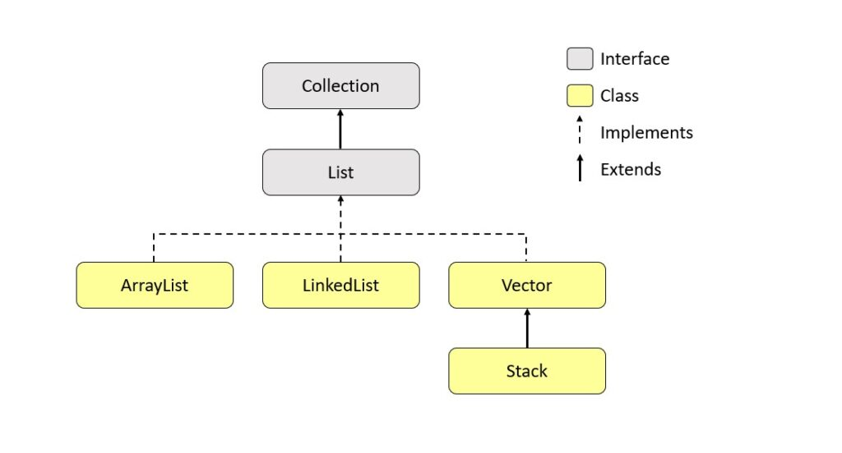 | - Duplicates are allowed  - Multiple nulls allowed  - Maintains Insertion order
The difference is that, the elements in List can be of different types.
You can restrict the type in List by using List<> instead of List.
//List allows heterogenious data  List arr1 = new ArrayList();  list.add(1)  list.add("a");  System.out.println(list);  OUTPUT:-  [1, a] | // List<> allows homogenious datas  List<Integer> list = new ArrayList<Integer>();  list.add(1)  list.add(2);  System.out.println(list);  OUTPUT:-  [1, 2]

INTERVIEW QUESTION:-

Differentiate ArrayList and Vector

ArrayList | Vector
Not synchronized  ArrayList have default capacity of 10. ArrayList increments the size by 50%.  No way to increment the size  ArrayList uses Iterator interface to iterarte  Example: | Synchronized  Vector have the default capacity of 10. Vector will be increment the size by double.  Vector size can be incremented byusing size(int size) method  uses both Enumeration and Iterator interfaces to iterate  Example:
List<Integer> list = new ArrayList<Integer>();  list.add(1);  list.add(2);  List<Integer> l2 = new ArrayList<Integer>();  l2.add(3);  l2.add(4);  l2.add(5);  list.addAll(1, l2);  System.out.println(list.get(2));  list.set(3, 7); // index, object  list.remove(1);  //convert list to array  Object[] arr = list.toArray();  // searching  System.out.println(list.indexOf(2));  System.out.println(list. lastIndexOf(2));  System.out.println(list.subList(1,3));  // list traverses in either direction using  Iterator iter = list.listIterator(1);  while (iter.hasNext()) {  System.out.println (iter.next());  }  /* simillarly for backward iteration hasPrevious()& previous()can be used*/  // ver. 1 for-loop  for (int i=0; i < list.size() ; i++) {  System.out.println(list[i]);  }  // ver. 2 for-loop  for (Object elem : list)  System.out.println(elem); | Vector vec1 = new Vector();  // Creating Vector with initial capacity 5  Vector vec2 = new Vector(5);  /* Creating the Vector with initial capacity is 3 and increment value is 2*/  Vector vec3 = new Vector(3, 2);  vec1.add(200)  vec1.insertElementAt(100, 1)  vec1.contains(900)  vec1.get(4)  vec1.elementAt(4)
INTERVIEW QUESTION:-

GUESS THE O/P

If list = [4,5,7,8,2], what is the result of the following code:

System.out.println(list.set(4,10));
Ans:- 2
public E set(int index, E element)
Returns Value: This method returns the element previously at the specified position.

INTERVIEW QUESTION:-
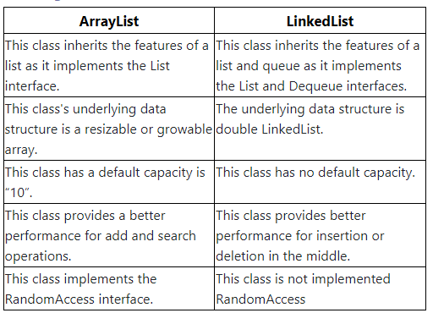

STACK:-
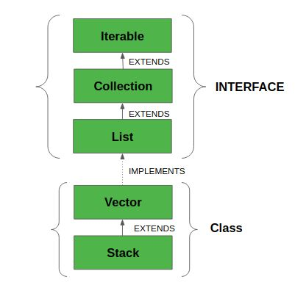 | The Java collections framework has a class named Stack that provides the functionality of the stack data structure.  It represents a LIFO (last in, first out) collection of objects allowing for pushing/popping elements  If the number of added elements exceeds the total Stack size, it will be doubled utomatically.  However, its size will never shrink after removing elements.  This will create a Stack with the default capacity of 10.
Example:-
Stack<String> animals= new Stack<>();
System.out.println("Is the stack empty? " + animals.empty());
animals.push("Dog");
animals.push("Horse");
animals.push("Cat");
System.out.println("Stack: " + animals);
System.out.println("Removed Element: " + animals.pop());
System.out.println("Element at top: " + animals.peek());
System.out.println("Position of Horse: " + animals.search("Horse"));

INTERVIEW QUESTION:-
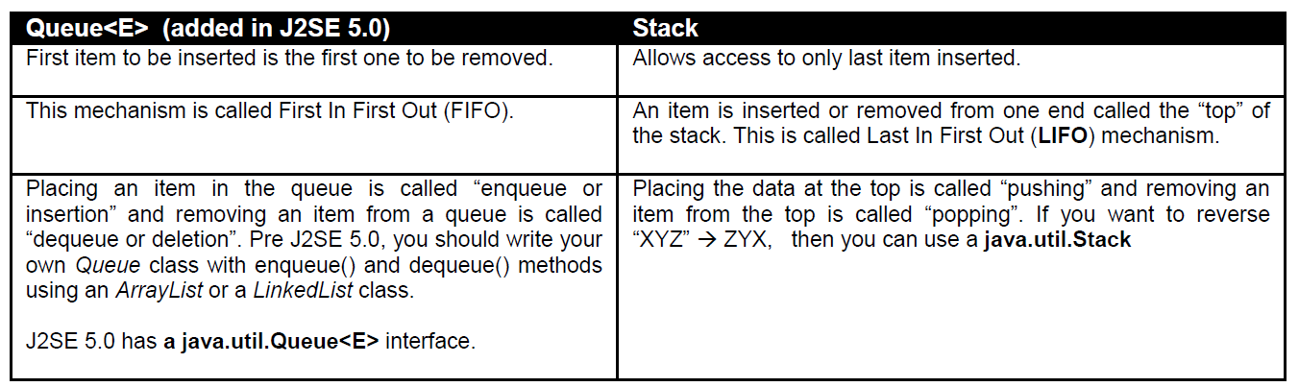

Set:-
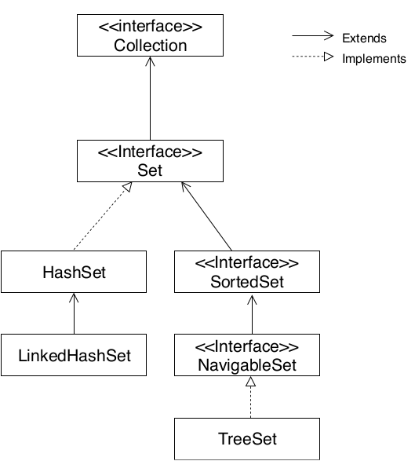 | No Duplicates  One null allowed  Doesnot maintain the order of insertion Based on the hash code of the values, the order is confirmed

HashSet | LinkedHashSet | TreeSet
Uses Hash Map  Can store heterogenious data  Allows null value  Faster  Does not maintain the insertion order | Uses Linked List  Can store heterogenious data  Allows null value  maintain the insertion order | Uses Tree  Can store Only homogenious data  Doesnot allow null value  Maintains ascendingorder.
Set set = new HashSet();  set.add("A");  set.add("M");  set.add("b");  set.add(4);  set.add(1);  set.add(9);  OUTPUT:-  set : [A, 1, b, 4, 9, M] | Set set = new LinkedHashSet();  set.add("A");  set.add("M");  set.add("b");  set.add(4);  set.add(1);  set.add(9);  OUTPUT:-  set : [A, M, b, 4, 1, 9] | Set set = new TreeSet();  set.add(1);  set.add(2);  set.add(4);  set.add(4);  set.add(1);  set.add(9);  OUTPUT:-  set : [1, 2, 4, 9]

MAP:-
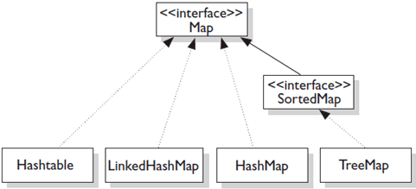
A map contains key and value pair
Each key and value pair is known as an entry

HashMap | LinkedHashMap | TreeMap
Key are unique, but values can be duplicated  Null keys & values allowed  unordered | Key are unique, but values can be duplicated  Null keys & values allowed  Maintains Insertion order | Key are unique, but values can be duplicated  Null keys & values not allowed  Maintains ascending order

NOTE:- A Map can't be traversed, so you need to convert it into Set using keySet() or entrySet() method.
Example:-
Map<Integer,String> numbers = new HashMap<>();
numbers.put(2,"Two");
numbers.put(1,"One");
numbers.put(4,"Four");
numbers.put(3,"Three");
numbers.put(6,"Six");
numbers.put(5,"Five");
System.out.println("Map: " + numbers);
System.out.println("Keys: " + numbers.keySet());
System.out.println("Values: " + numbers.values());
System.out.println("Entries: " + numbers.entrySet());
System.out.println("Removed Value: " + numbers.remove(2)) ;
//Traversing Map
Set set=numbers.entrySet();//Converting to Set so that we can traverse
Iterator itr=set.iterator();
while(itr.hasNext()){
//Converting to Map.Entry to print key and value separately
Map.Entry entry=(Map.Entry)itr.next();
System.out.println(entry.getKey()+" "+entry.getValue());
}

INTERVIEW QUESTION:-
How to check equality of 2 objects?
[OR]
What is the difference between “==” and equals(…) method? What is the difference between shallow comparison and deep comparison of objects?

It is done by using equals(Object) method of java.lang.Object class

Two types of checking the equality
Shallow comparision--- checks whether 2 objects refer to same object
Deep comparition---- classes provid own implementation of equal(Object)method

Example:-
Student s1=newStudent(1,”Ravi”);
Student s2=newStudent(1,”Ravi”);
System.out.println(s1==s2);
// although 2 objects s1 & s2 has same values they are not equal since they have different hashcode.

Some we have to override equals(Object) for checking equality of 2 objects.
Public boolean equals(Object obj){
if(obj==null)
returnfalse;
if(!(obj instanceOf Student))
return false;
if(this.getId()==((Student)obj.getId())
return true;
}
}
implementation of equals() and hashCode() should follow these rules.
- If o1.equals(o2), then o1.hashCode() == o2.hashCode() should always be true.
- If o1.hashCode() == o2.hashCode is true, it doesn’t mean that o1.equals(o2) will be true.
INTERVIEW QUESTION:-

Why do you get a ConcurrentModificationException when using an iterator?
The java.util Collection classes are fail-fast, which means that if one thread changes a collection while another
thread is traversing it through with an iterator the iterator.hasNext() or iterator.next() call will throw
ConcurrentModificationException. Even the synchronized collection wrapper classes SynchronizedMap and SynchronizedList are only conditionally thread-safe, which means all individual operations are thread-safe but compound
operations where flow of control depends on the results of previous operations may be subject to threading issues.

INTERVIEW QUESTION:-
What is marker interface?
An interface that does not have any methods, fields, or constants, i.e, an empty interface in java is known as Marker or Tag Interface. It is used to deliver type information at runtime to the JVM so that it can take some action based on the information received.
Example:-
Serializable interface is a marker interface. The marker interface provides a hint to the Java runtime that the implementing class allows itself to be serialized.

INTERVIEW QUESTION:-
Object cloning?

Class Student implements clonable{
-------
}

Student S1= new Student(1,”Hari”);
Student S2= (Student)S1.clone();

